A Project Report On

Placement Preparation Portal

Submitted in partial fulfillment of the requirement for the award of the degree

Master of Computer Applications
(MCA)

Academic Year 2026 – 27

Jethava Hardik 92500584003
Vala Hardik 92500584013

Internal Guide
Dr. Divyakant Meva

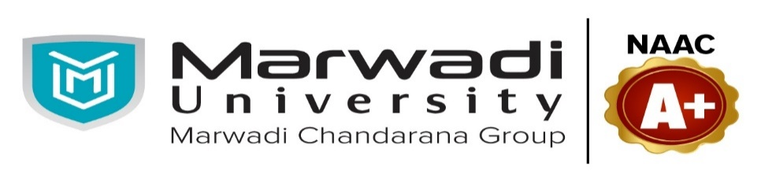

Rajkot-Morbi Road, At &PO :Gauridad, Rajkot 360 003. Gujarat. India.


Faculty of Computer Applications (FoCA)



This is to certify that the project work entitled
Placement Preparation Portal

submitted in partial fulfillment of the requirement for

the award of the degree of
Master of Computer Applications (MCA)

of the

Marwadi University

is a result of the bonafide work carried out by

Hardik Jethava 92500584003

Hardik Vala 92500584013

during the academic year 2026-27

Dr. Divyakant Meva Dr. Sunil Bajeja Dr. Rijwan Khan
Faculty Guide |  | HOD |  | Dean

DECLARATION

I hereby declare that the project entitled “Placement Preparation Portal” has been developed by me as part of the academic requirements for the Master of Computer Applications (MCA) programme at Marwadi University.
I further declare that the work presented in this project report is based on my own efforts, study, design, and development. The project has been developed using technologies including React.js, Vite, Tailwind CSS, Node.js, Express.js, MongoDB, Mongoose, JWT, bcryptjs, and Axios.
I have made every effort to ensure that the information, analysis, design, and implementation details presented in this report are accurate to the best of my knowledge. This project report has not been submitted previously to any other university or institution for the award of any degree or qualification.
.

Place:
Date:

Hardik Jethava 92500584003 Signature: ___________
Hardik Vala 92500584026 Signature:___________

ACKNOWLEDGEMENT

It is indeed a great pleasure to express our thanks and gratitude to all those who helped us. No serious and lasting achievement or success one can ever achieve without the help of friendly guidance and co-operation of so many people involved in the work.

We are very thankful to our guide Dr.Divyakant Meva, the person who makes us to follow the right steps during our project work. We express our deep sense of gratitude to for his /her guidance, suggestions and expertise at every stage. A part from that his/her valuable and expertise suggestion during documentation of our report indeed help us a lot.

Thanks to our friend and colleague who have been a source of inspiration and motivation that helped to us during our project work.

We are heartily thankful to the Dean of our department Dr. Rizwan Khan sir and HoD Dr. Sunil Bajeja sir for giving us an opportunity to work over this project and for their end-less and great support to all other people who directly or indirectly supported and help us to fulfil our task.

Hardik Jethava 92500584003 Signature:_ __________
Hardik Vala 92500584013 Signature:___________

CONTENTS

Chapters | Particulars | Page No.
1 | Introduction to Project Definition | 8
2  2.1  2.2  2.3  2.4  2.5 | PREAMBLE  Synopsis  Problem Statement  Objectives of the System  Scope of the System  Module description | 9
3 | REVIEW OF LITERATURE  Analyse, Study and Compare the similar types of the systems/applications and highlights major findings | 18
4  4.1  4.2 | TECHNICAL DESCRIPTION  Hardware Requirement  Software Requirement | 20
5  5.1  5.2  5.3  5.4  5.5  5.6  5.7  5.8 | SYSTEM DESIGN AND DEVELOPMENT  - Flow Chart  - Data Flow Diagram  - Use Case Diagram  - Sequential Diagram  - Class Diagram  - Activity Diagram  - Database Design / File Structure (If applicable)  - Menu Design, Screen Design | 23
6 | SYSTEM TESTING | 50
7 | CONCLUSION | 56
8  8.1 | LEARNING DURING PROJECT WORK  Future Enhancement | 57
9  9.1  9.2 | BIBLIOGRAPHY  Online References  Offline References | 59

Table Index

Table No. | Title | Page No.
Table 3.1 | Comparative Analysis Matrix | 20
Table 4.1 | Hardware Requirement | 20
Table 4.2 | Software Requirement | 21
Table 4.3 | Network & Connectivity Requirements | 21
Table 6.1 | User Registration Testing | 50
Table 6.2 | User Authentication & Login Test Case | 51
Table 6.3 | Product & Inventory Management Testing | 53
Table 6.4 | Sales & Point of Sales (POS) Test Case | 54

Figure Index
Table No. | Title | Page No.
Figure 5.1 | Flow Chart | 19
Figure 5.2.1 | DFD Level 0 | 20
Figure 5.2.2 | DFD Level 1 | 21
Figure 5.3 | Use case diagram | 22
Figure 5.4 | Sequential Diagram | 23
Figure 5.5 | Class Diagram | 24
Figure 5.6 | Activity Diagram | 25
Figure 5.7.1 | Activities | 30
Figure 5.7.2 | Admin Activities | 30
Figure 5.7.3 | Announcement | 31
Figure 5.7.4 | Bookmark | 31
Figure 5.7.5 | Coding Notes | 32
Figure 5.7.6 | Coding Program | 32
Figure 5.7.7 | Coding Submission | 33
Figure 5.7.8 | Companies | 33
Figure 5.7.9 | Interview Questions | 34
Figure 5.7.10 | Notification | 34
Figure 5.7.11 | Question Report | 35
Figure 5.7.12 | Questions | 35
Figure 5.7.13 | Results | 36
Figure 5.7.14 | Resume Scans | 36
Figure 5.7.15 | Test | 37
Figure 5.7.16 | Topic Notes | 37
Figure 5.7.17 | Users | 38
Figure 5.7.18 | Vocabulary | 38
Figure 5.8.1 | Student Login Screen | 40
Figure 5.8.2 | Student Register Screen | 40
Figure 5.8.3 | Student Dashboard Screen | 41
Figure 5.8.4 | Aptitude Pre | 42
Figure 5.8.5 | Reasoning Pre | 42
Figure 5.8.6 | verbal Ability & English Pre | 42
Figure 5.8.7 | Coding Practise | 43
Figure 5.8.8 | Mock Test | 43
Figure 5.8.9 | Resume Scanning | 43
Figure 5.8.10 | Company Preparation | 44
Figure 5.8.11 | Performance Analysis | 44
Figure 5.8.12 | Student Profiles | 44
Figure 5.9.1 | Admin Login | 45
Figure 5.9.2 | Admin Dashboard | 45
Figure 5.9.3 | Announcement | 46
Figure 5.9.4 | Student Management | 46
Figure 5.9.5 | Coding Practise | 46
Figure 5.9.6 | Aptitude Bank | 47
Figure 5.9.7 | Reasoning Bank | 47
Figure 5.9.8 | English Bank | 47
Figure 5.9.9 | Companies | 48
Figure 5.9.10 | Mock Test | 48
Figure 5.9.11 | Results & Attempt | 48
Figure 5.9.12 | Resume Scanning | 49
Figure 5.9.13 | Notification | 49
Figure 5.9.14 | Report Data & Export | 49
Figure 5.9.15 | Audit Logs | 50
Figure 5.9.16 | Settings | 50

- Introduction to Project Definition

The Placement Preparation Portal is a web-based platform designed to provide students with a complete and structured environment for preparing for campus placements. Students generally use different websites and applications for aptitude preparation, reasoning, English, programming, coding practice, company-specific questions, mock tests, interview preparation, and resume improvement. Managing preparation across multiple platforms can be time-consuming and makes it difficult to track overall progress.

The proposed Placement Preparation Portal solves this problem by bringing all major placement-preparation activities into a single platform. Students can study preparation notes, practice topic-wise questions, attempt quizzes and mock tests, solve coding problems, prepare for specific companies, scan and improve their resumes, and monitor their performance through a personalized dashboard.

The system consists of two major panels:
- Student Panel: Provides access to learning materials, aptitude, reasoning, English, coding practice, mock tests, company preparation, Resume Scanner, AI Insights, and Analytics.
- Admin Panel: Allows administrators to manage students, notes, questions, coding problems, companies, mock tests, results, and other preparation content dynamically.

The project is developed using the MERN Stack, consisting of MongoDB, Express.js, React.js, and Node.js, along with technologies such as Mongoose, JWT, bcryptjs, Axios, React Router, and Tailwind CSS.

The main purpose of the project is to create a single, dynamic, user-friendly, and data-driven placement preparation system where students can follow the complete preparation cycle:

Learn → Practice → Test → Analyze → Improve

Through progress tracking and result analysis, students can identify their strengths and weaknesses and improve their placement readiness systematically.

- PREAMBLE

  - Synopsis :

The Placement Preparation Portal is a comprehensive, web-based student placement preparation system designed to provide all essential placement preparation resources through a single centralized platform. The main purpose of the system is to help students prepare systematically for different stages of campus recruitment, including aptitude examinations, reasoning tests, English assessments, technical coding rounds, company-specific examinations, technical interviews, HR interviews, and resume evaluation.

In the traditional placement preparation process, students generally depend on multiple websites, YouTube videos, books, coding platforms, and other resources. This makes preparation difficult to organize and makes it challenging for students to determine their actual preparation level. The Placement Preparation Portal addresses these problems by integrating different preparation activities into one unified web application.

The system follows a complete preparation cycle:
Learn → Practice → Quiz → Mock Test → Analyze Result → Identify Weak Areas → Improve

The application contains two major user panels: Student Panel and Admin Panel. Each panel has a different purpose and role-based access.

  - Problem Statement :

Students preparing for campus placements generally depend on multiple websites and applications for different preparation requirements such as aptitude, reasoning, English, programming, coding problems, mock tests, company-specific questions, interview preparation, and resume improvement.
This fragmented approach creates several problems:

- Difficulty in finding all preparation material in one place.
- Lack of structured topic-wise preparation.
- Difficulty in tracking individual progress.
- Limited performance analysis.
- Separate platforms for coding, aptitude, reasoning, and English.
- Difficulty in preparing according to specific companies.
- Lack of centralized mock-test results.
- Difficulty in identifying strong and weak areas.

Therefore, there is a need for a single integrated placement preparation platform that provides students with learning, practice, testing, analysis, and career preparation facilities.

  - Objectives of the System :

The main objectives of the Placement Preparation Portal are:
1. Develop a Centralized Platform for Student Placement Preparation
The system provides a single platform where students can prepare for different placement stages.
It brings aptitude, reasoning, English, coding, interviews, and company preparation together.

2. Provide Topic-Wise Preparation Notes and Study Material
Students can access organized notes and learning materials for individual topics.
This allows students to understand concepts before attempting practice questions and tests.

3. Provide Aptitude, Reasoning, and English Practice Questions
The portal provides subject-wise and topic-wise questions for regular practice.
Students can solve MCQs, quizzes, and practice sets to improve their examination performance.

4. Provide Programming Language and Coding Preparation
Students can learn important programming languages and technical concepts required for placement interviews.
The system provides programming theory, examples, interview questions, and coding-related practice.

5. Provide Coding Challenges with Different Difficulty Levels
The Coding Practice module provides coding problems categorized as Easy, Medium, and Hard.
This enables students to gradually improve their problem-solving and programming skills.

6. Conduct Quizzes and Timed Mock Placement Tests
Students can participate in topic-wise quizzes and complete placement-style mock examinations.
Timers, question navigation, auto-submission, and scoring make the tests similar to real examinations.

7. Provide Company-Specific Placement Preparation
The portal provides preparation resources based on individual companies and their recruitment patterns.
Students can study selection processes, aptitude, coding, technical, and HR interview questions.

8. Provide a Resume Scanner for Resume Review and Improvement
Students can upload their resumes and receive resume-related analysis and improvement suggestions.
The module helps students identify areas that may need improvement before applying for placements.

  - Scope of the System :

A. In-Scope Modules & Features

The following modules and features are included in the proposed Placement Preparation Portal:
1. Student Authentication & Profile
- Student registration and login.
- JWT-based authentication and role-based access.
- Profile management, password change, and logout.

2. Student Dashboard
- Placement readiness score.
- Daily and overall progress.
- Study streak and completed topics.
- Recent activity, bookmarks, recommendations, and notifications.
- Performance charts and preparation overview.

3. Aptitude Preparation
- Topic-wise notes and study material.
- MCQs and practice questions.
- Topic-wise quizzes.
- Timed mock tests.
- Test results and performance analysis.
- Topics such as Number System, Percentage, Profit & Loss, Average, Ratio, Time & Work, Probability, SI, CI, and others.

4. Reasoning Preparation
- Logical and analytical reasoning notes.
- Topic-wise examples and practice questions.
- MCQs and quizzes.
- Mock tests with timer.
- Results, explanations, bookmarks, and progress tracking.

5. English Preparation
- Grammar and vocabulary preparation.
- Synonyms, antonyms, idioms, and one-word substitution.
- Reading comprehension.
- Sentence correction and error detection.
- Quizzes, mock tests, results, and progress tracking.

6. Programming Languages
- Preparation material for C, C++, Java, Python, JavaScript, PHP, SQL, HTML, CSS, React, Node.js, Express.js, and MongoDB.
- Programming concepts, syntax, examples, programs, MCQs, and interview questions.

7. Coding Practice
- Data Structures and Algorithms preparation.
- Arrays, Strings, Stack, Queue, Linked List, Trees, Graphs, Sorting, Searching, Recursion, and Dynamic Programming.
- Coding challenges categorized into Easy, Medium, and Hard.
- Hints, solutions, explanations, bookmarks, search, filters, and progress tracking.

8. Company Preparation
- Company-specific placement preparation.
- Selection process information.
- Aptitude, coding, technical, and HR questions.
- Interview experiences and preparation tips.
- Company-wise search and filtering.

9. Mock Test System
- Aptitude, Reasoning, English, Coding, and Mixed Placement Tests.
- Timer and question navigation.
- Auto-submit and negative marking.
- Score calculation and detailed result analysis.
- Test history and performance tracking.

10. Resume Scanner
- Resume upload and storage.
- Resume review and analysis.
- Suggestions for improving resume content.
- Identification of potential missing or weak areas.
- AI-assisted resume analysis where configured.

11. AI Preparation
- AI-generated HR interview questions.
- Technical interview question generation.
- Resume suggestions.
- Skill-gap analysis.
- Personalized learning roadmap.
- Mock interview feedback.
- Career-related suggestions.

12. Progress & Analytics
- Daily, weekly, and monthly progress.
- Topic-wise performance.
- Coding performance.
- Mock test history.
- Accuracy and scores.
- Strong and weak areas.
- Placement readiness tracking.

13. Admin Panel
- Admin authentication and dashboard.
- Student management.
- Notes management.
- Aptitude, Reasoning, and English question banks.
- Coding problem management.
- Company management.
- Mock test management.
- Results and attempts management.
- Reports and analytics.
- Dynamic CRUD operations.

14. Database & API Integration
- MongoDB-based data storage.
- Mongoose database models.
- REST APIs using Node.js and Express.js.
- Frontend-backend integration using Axios.
- Dynamic content delivery from Admin Panel to Student Panel.

B. Out-of-Scope (Future Boundaries)

The following features are outside the primary scope of the current system and may be considered for future enhancement:
1. Online Compiler Infrastructure
A fully secure online code execution environment for running student programs in multiple programming languages is not part of the current core scope.

2. Real-Time AI Voice Interview
Real-time voice-based interviews with speech recognition, voice analysis, and conversational AI can be implemented as a future enhancement.

3. Direct Company Recruitment
The portal does not directly conduct company recruitment, job offers, or hiring processes.

4. Live Placement Drives
Managing real-time campus placement drives, interview scheduling, candidate selection, and offer management is outside the current scope.

5. Mobile Application
A dedicated Android or iOS application is not included in the current web-based implementation and may be developed in the future.

6. Advanced Job Matching
Automatic matching of student profiles with live job vacancies based on skills, experience, and eligibility can be added in a future version.

7. Advanced Resume Parsing
More advanced resume parsing, ATS simulation, job-specific resume optimization, and automated job matching can be added later.

8. External Placement Data Integration
Direct integration with external job portals, company recruitment systems, or third-party placement databases is outside the current scope.

9. Multilingual Learning
Providing complete preparation content in multiple regional languages can be considered as a future enhancement.

10. Advanced Predictive Analytics
Advanced machine-learning models for predicting placement probability, salary range, or company selection probability are outside the current implementation boundary.

Scope Summary
In-Scope:
Learn → Practice → Quiz → Mock Test → Result → Analysis → Improvement
Future Scope:
AI Voice Interview → Online Compiler → Job Matching → Mobile App → Advanced Predictive Analytics → Live Recruitment Integration

2.5 Module description :

1. Authentication Module
This module provides secure registration and login for Students and Admins. It includes JWT authentication, password management, profile updates, and role-based access control.

2. Student Dashboard Module
This module provides students with an overview of their placement preparation and performance. It displays progress, readiness score, study streak, completed topics, activities, and recommendations.

3. Aptitude Module
This module helps students prepare for quantitative aptitude through topic-wise notes, examples, MCQs, quizzes, and mock tests. It also provides timers, results, explanations, and performance tracking.

4. Reasoning Module
This module provides preparation for logical and analytical reasoning topics commonly asked in placement examinations. Students can study notes, practice questions, attempt quizzes and mock tests, and track their progress.

5. English Module
This module improves students' English and verbal ability through grammar, vocabulary, comprehension, sentence correction, and other placement-related topics. It provides study material, practice questions, quizzes, and mock tests.

6. Programming Languages Module
This module provides theoretical and practical preparation for important programming languages and technologies. Students can learn concepts, syntax, examples, programs, MCQs, and interview questions.

7. Coding Practice Module
This module helps students improve programming and problem-solving skills through Data Structures and Algorithms. It provides coding challenges categorized into Easy, Medium, and Hard levels along with solutions, hints, explanations, and progress tracking.

8. Company Preparation Module
This module provides company-specific placement preparation resources. Students can study selection processes, aptitude, coding, technical and HR questions, interview experiences, and preparation tips.

9. Mock Test Module
This module allows students to take placement-oriented tests for Aptitude, Reasoning, English, Coding, and Mixed subjects. It includes timers, question navigation, auto-submit, negative marking, scoring, and detailed result analysis.

10. Resume Scanner Module
This module allows students to upload their resumes and receive resume-related analysis and improvement suggestions. It is designed to help students identify missing information and improve the quality of their resumes.
11. AI Preparation Module
This module provides AI-assisted placement preparation such as HR and technical interview questions, resume suggestions, skill-gap analysis, learning roadmaps, and interview feedback.

12. Progress & Analytics Module
This module analyzes student preparation and displays daily, weekly, and monthly performance. It tracks accuracy, completed topics, coding progress, mock-test history, strengths, weaknesses, and placement readiness.

13. Admin Module
This module allows administrators to manage the complete portal and its content. Admins can manage students, notes, questions, coding problems, companies, mock tests, results, reports, and analytics through dynamic CRUD operations.

3. REVIEW OF LITERATURE

The Placement Preparation Portal is based on the study of existing online learning, coding practice, aptitude preparation, mock-test, resume analysis, and interview preparation platforms. The review of existing systems helps identify their useful features as well as the limitations that can be addressed through an integrated placement preparation platform.

3.1 Online Learning Platforms
Online learning platforms provide students with structured courses, study materials, videos, quizzes, and assessments. These platforms demonstrate the importance of organizing educational content according to subjects and topics. However, general learning platforms are not specifically focused on the complete campus placement preparation process.

3.2 Coding Practice Platforms
Coding practice platforms provide programming problems based on different topics and difficulty levels. Features such as problem-solving, hints, solutions, explanations, and progress tracking are useful for technical placement preparation. The proposed system incorporates similar coding-practice concepts while combining them with aptitude, reasoning, English, company preparation, and mock tests.

3.3 Aptitude and Reasoning Preparation Systems
Aptitude and reasoning preparation websites generally provide topic-wise questions, MCQs, explanations, quizzes, and practice tests. These systems are useful for preparing for the assessment rounds of companies. The proposed portal integrates these preparation areas into the same platform and connects their results with the student's overall progress.

3.4 Mock Test Systems
Online examination systems provide features such as timers, question navigation, automatic submission, scoring, and result analysis. These features are important for simulating real placement examinations. The Placement Preparation Portal extends this concept by providing aptitude, reasoning, English, coding, and mixed placement mock tests.

3.5 Company-Specific Preparation
Company preparation platforms provide information about recruitment processes, frequently asked questions, coding problems, aptitude questions, and interview experiences. Such resources help students prepare according to specific company requirements. The proposed system includes a dedicated Company Preparation module to organize this information in one place.

3.6 Resume Analysis Systems
Resume-related systems help candidates create, review, or improve their resumes. Resume analysis can identify areas such as missing information, skills, formatting, and content quality. The proposed Resume Scanner module incorporates resume upload and review-oriented functionality and can be extended with AI-based suggestions.

3.7 AI-Based Interview Preparation
Recent AI-assisted career tools demonstrate the potential of artificial intelligence for generating interview questions, providing feedback, analyzing skills, and recommending learning paths. The proposed system includes an AI module for HR and technical interview questions, resume suggestions, skill-gap analysis, learning roadmaps, and interview feedback.

3.8 Research Gap
The review indicates that existing systems generally focus on a particular area such as coding, aptitude, online learning, mock testing, or resume preparation. Students may therefore need to use several different platforms for complete placement preparation.
The Placement Preparation Portal attempts to address this gap by integrating multiple preparation activities into one platform:

Study Material → Practice → Quiz → Mock Test → Result Analysis → Progress Tracking → Improvement

4. TECHNICAL DESCRIPTION

4.1 Hardware Requirement

This section specifies the empirical technical requirements verified directly from the MARKETA codebase (React 19.2.7, Vite 8.1.1, React-to-Print 3.3.0, Recharts 3.10.1, Axios 1.18.1, Inter Google Font, and responsive CSS layout engines) needed to open, run, and operate the web application on a user terminal.

Hardware Component | Minimum System Requirement | Recommended System Requirement
Device Category | Desktop PC, Laptop, POS Terminal, or Tablet | Desktop PC or Dedicated POS Touch Terminal
Processor (CPU) | Intel Core i3 / AMD equivalent | Intel Core i5 or higher
System Memory (RAM) | 3 GB DDR3 | 8 GB or higher
Storage | 10 GB free space | 20 GB or more
Display Resolution | 1366 × 768 resolution | Full HD 1920 × 1080
Internet | Basic broadband connection | Stable high-speed internet
Keyboard | Standard keyboard | Standard keyboard
Mouse | Standard mouse | Standard mouse
Table 4.1 Hardware Requirement

4.2 Software Requirement

The Placement Preparation Portal requires the following software and development technologies:
Software / Technology | Purpose
Windows / Linux / macOS | Operating System
Node.js | Backend runtime environment
React.js | Frontend development
Vite | React development and build tool
Tailwind CSS | User interface styling
React Router | Frontend navigation and routing
Express.js | Backend API development
MongoDB | Database management
Mongoose | MongoDB object modelling
JWT | Authentication and authorization
bcryptjs | Password hashing
Axios | Client-server API communication
Visual Studio Code | Development environment
Git/GitHub | Version control and source-code management
Postman | API testing
Web Browser | Application access and testing

Table 4.2 Software Requirement

Network & Connectivity Requirements :

The Placement Preparation Portal is a web-based application that requires a stable internet connection for communication between the Student/Admin frontend, backend server, database, and optional external services.

1. Internet Connection
A stable internet connection is required to access the portal, load preparation material, attempt tests, submit answers, and view results.

2. Recommended Internet Speed
A minimum internet speed of approximately 2 Mbps is recommended for normal usage. A faster connection provides better performance when loading large content or using AI-related features.

3. Client-Server Communication
The React frontend communicates with the Node.js and Express.js backend through HTTP/HTTPS REST APIs. Axios is used to send requests and receive responses from the server.

4. Database Connectivity
The backend server requires a network connection to communicate with the MongoDB database. Student profiles, questions, notes, tests, results, progress, and other application data are stored and retrieved through this connection.

5. HTTPS Security
For production deployment, HTTPS should be used to protect authentication credentials, API requests, and other sensitive information while data is transferred between the client and server.

6. AI and External Services
The optional AI features may require internet connectivity to communicate with an external AI API. Email-based features such as password reset or OTP verification may also require an SMTP service.

7. Local Development Network
During development, the frontend and backend may run on separate local ports, for example:
React/Vite Frontend → localhost → Express Backend → MongoDB
The frontend must be configured with the correct backend API URL.

8. Production Connectivity
After deployment, the system requires:

Student/Admin Browser → Internet → Hosted Frontend → Hosted Backend API → MongoDB

Browser Requirements
The application can be accessed using modern web browsers such as:
- Google Chrome
- Microsoft Edge
- Mozilla Firefox
- Safari

5. SYSTEM DESIGN AND DEVELOPMENT

5.1 Flow Chart:

Figure 5.1 Flow Chart
5.2 Data Flow Diagram:

Level 0:-

–––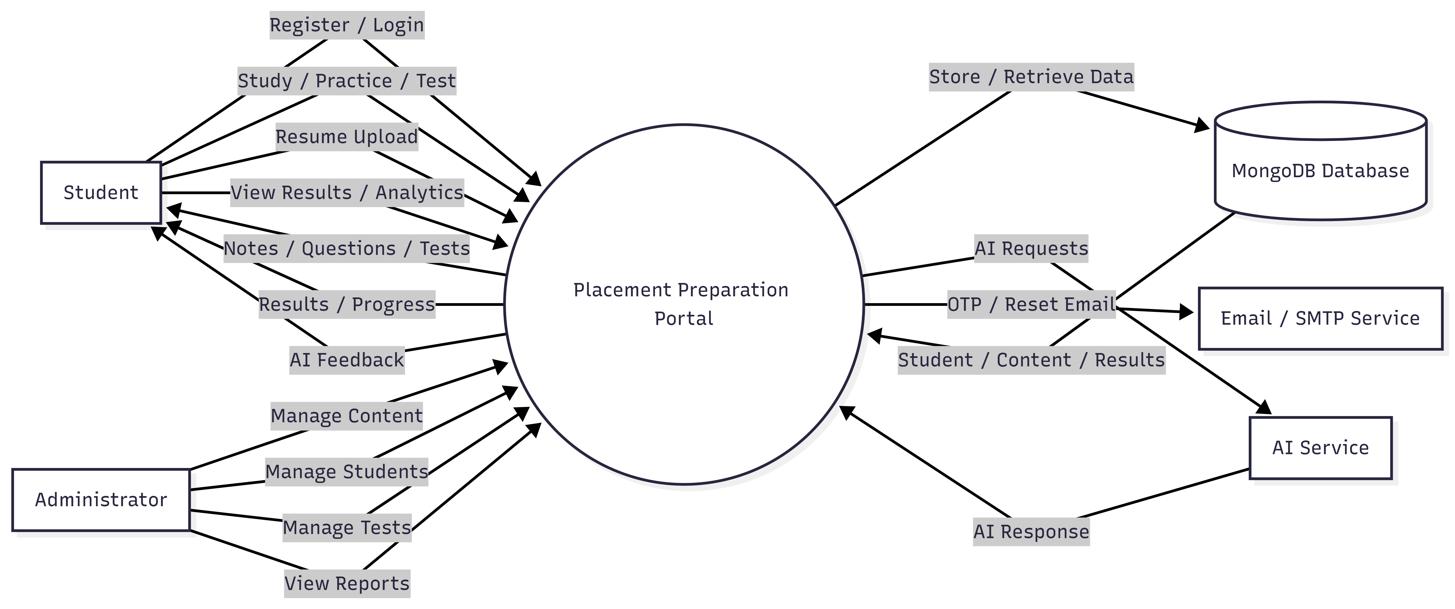

Figure 5.2.1 DFD Level 0

Level 1:-

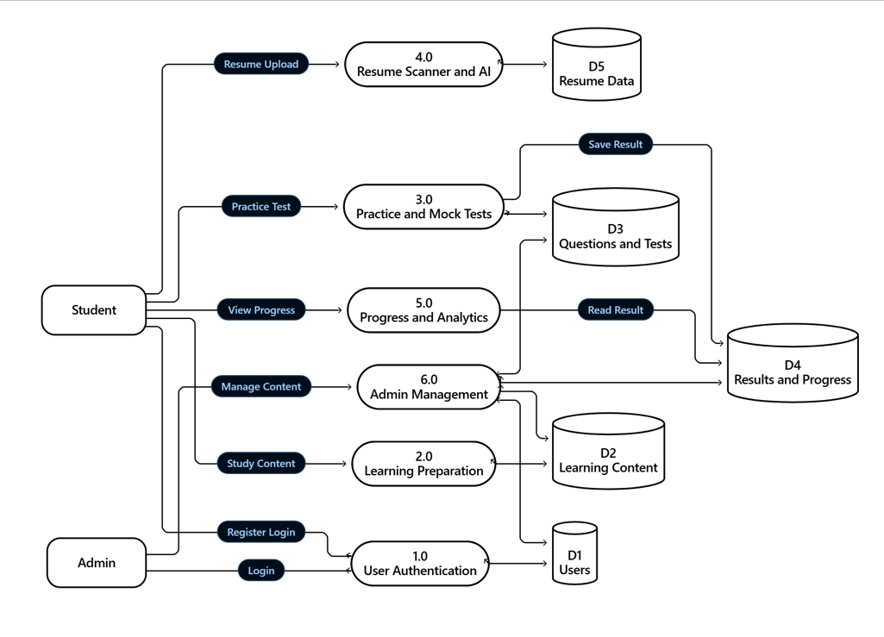

Figure 5.2.2 DFD Level 1

5.3 Use Case Diagram:
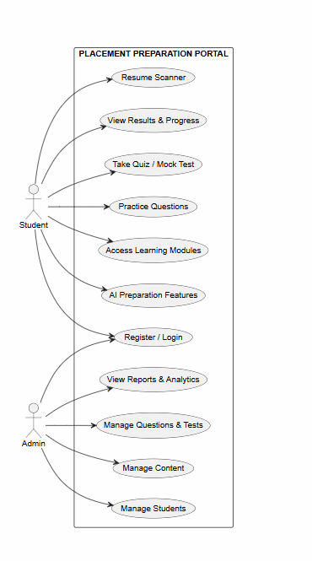

Figure 5.3 Use case diagram

5.4 Sequential Diagram:

Figure 5.4 Sequential Diagram
5.5 Class Diagram:
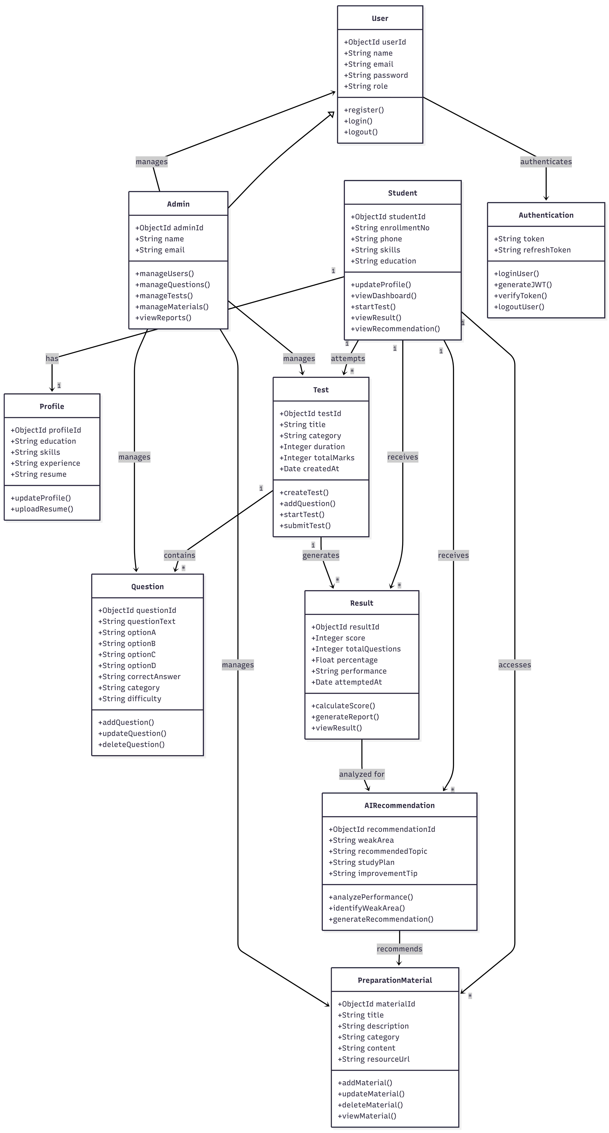

Figure 5.5 Class Diagram
5.6 Activity Diagram:

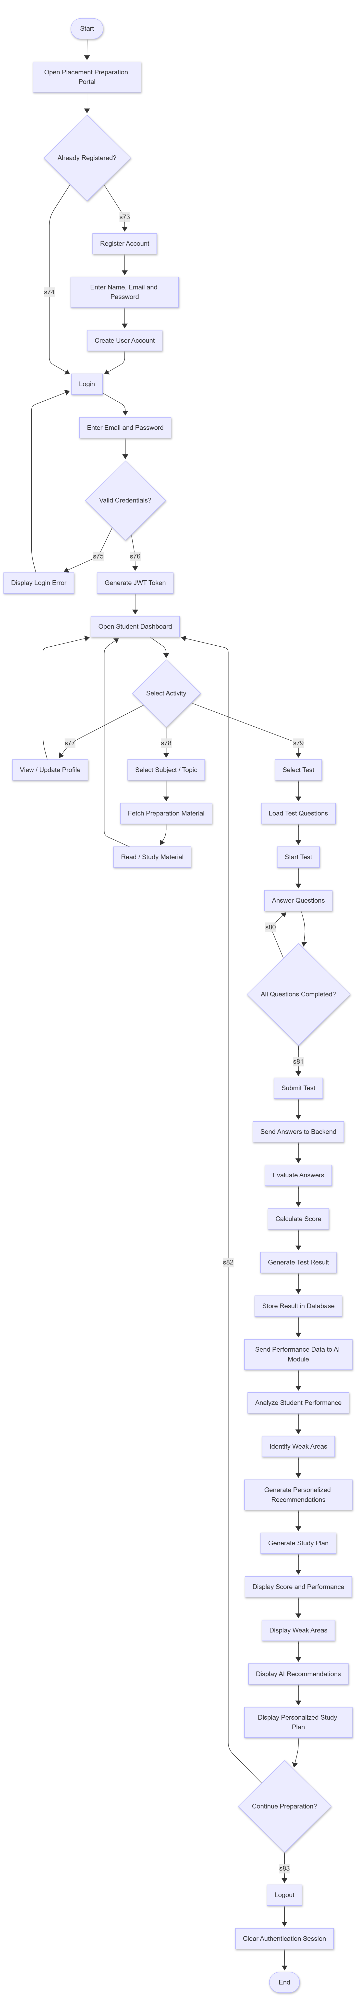

Figure 5.6 Activity Diagram
5.7 Database Design:

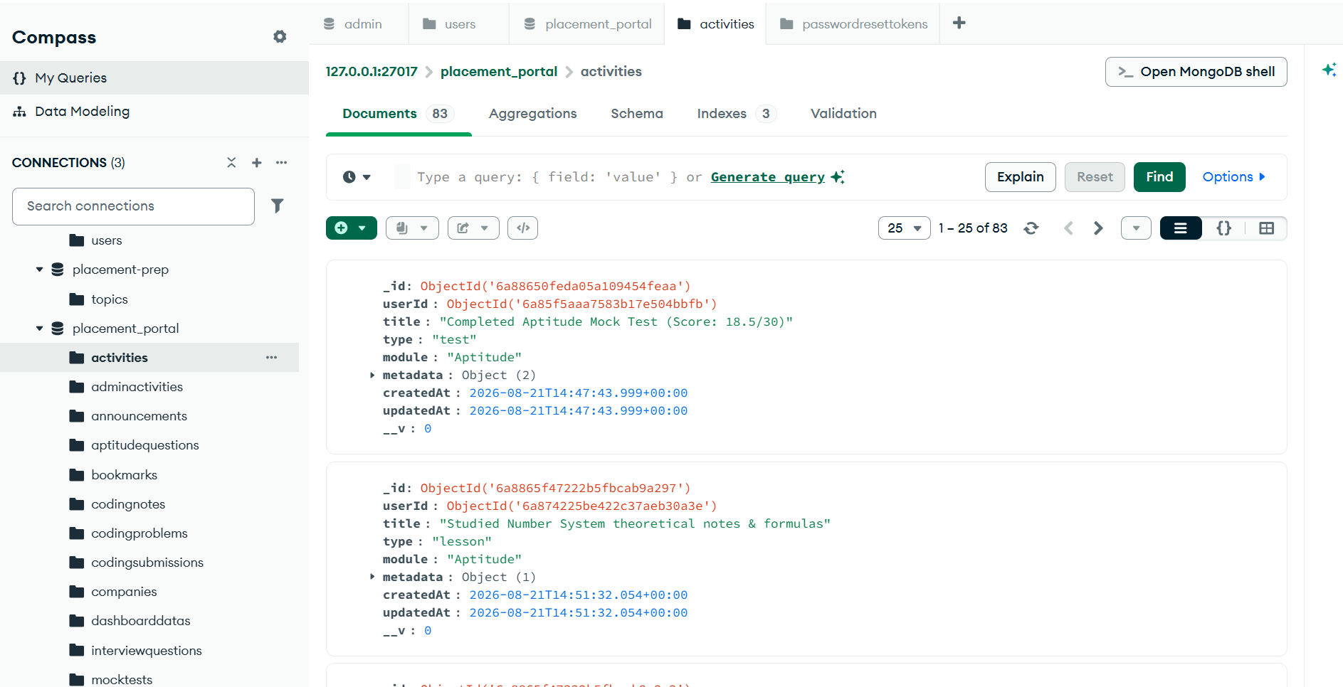
Figure 5.7.1 Activities

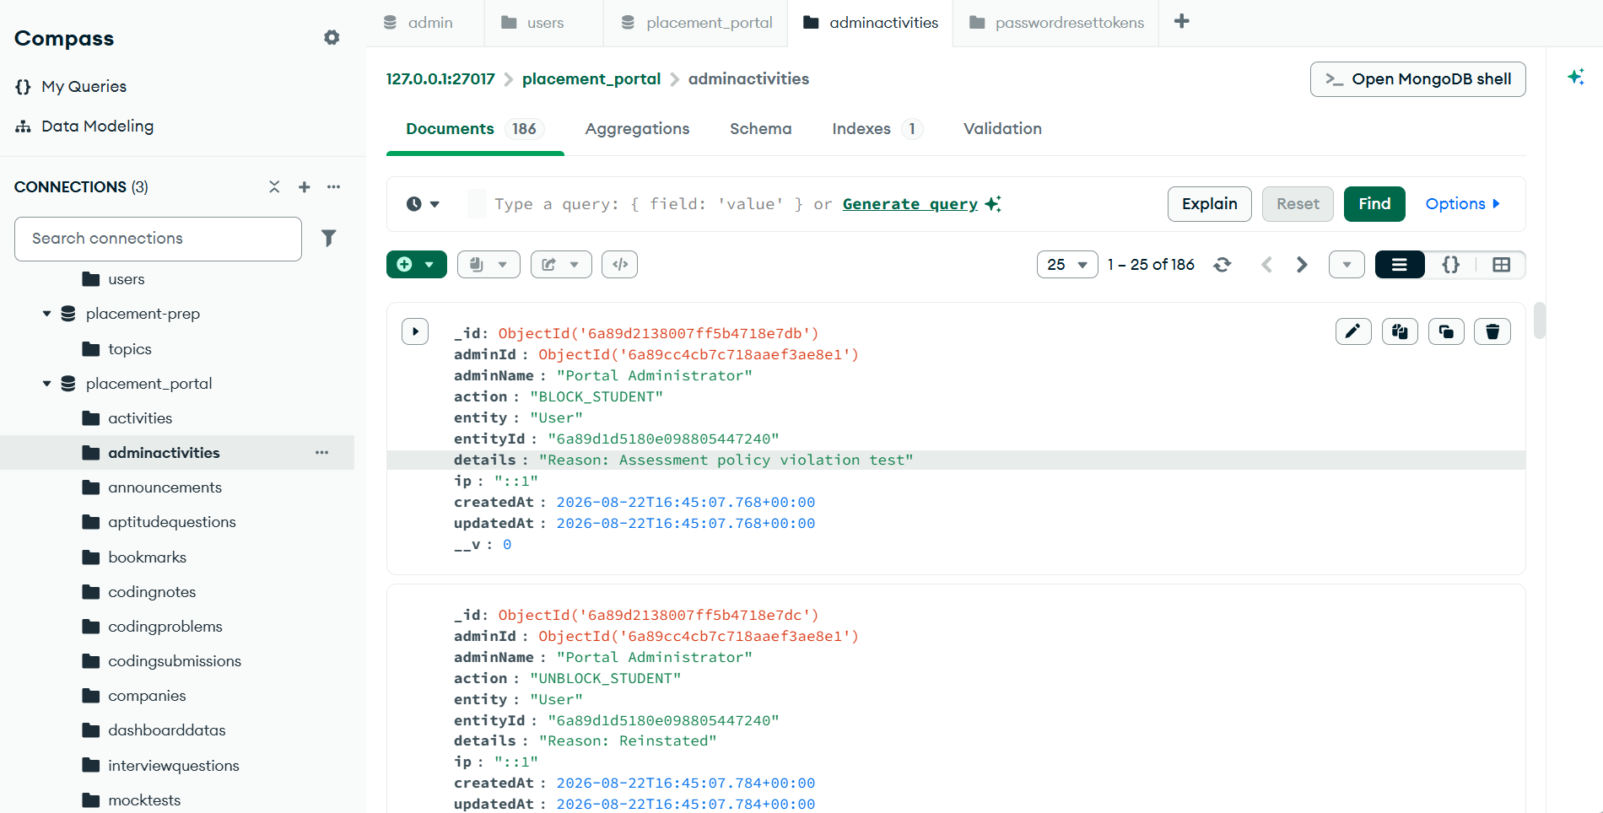
Figure 5.7.2 Adminactivities
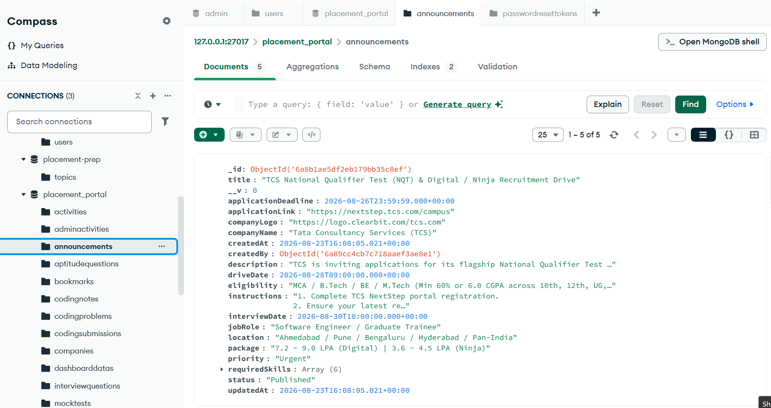
Figure 5.7.3 Announcement

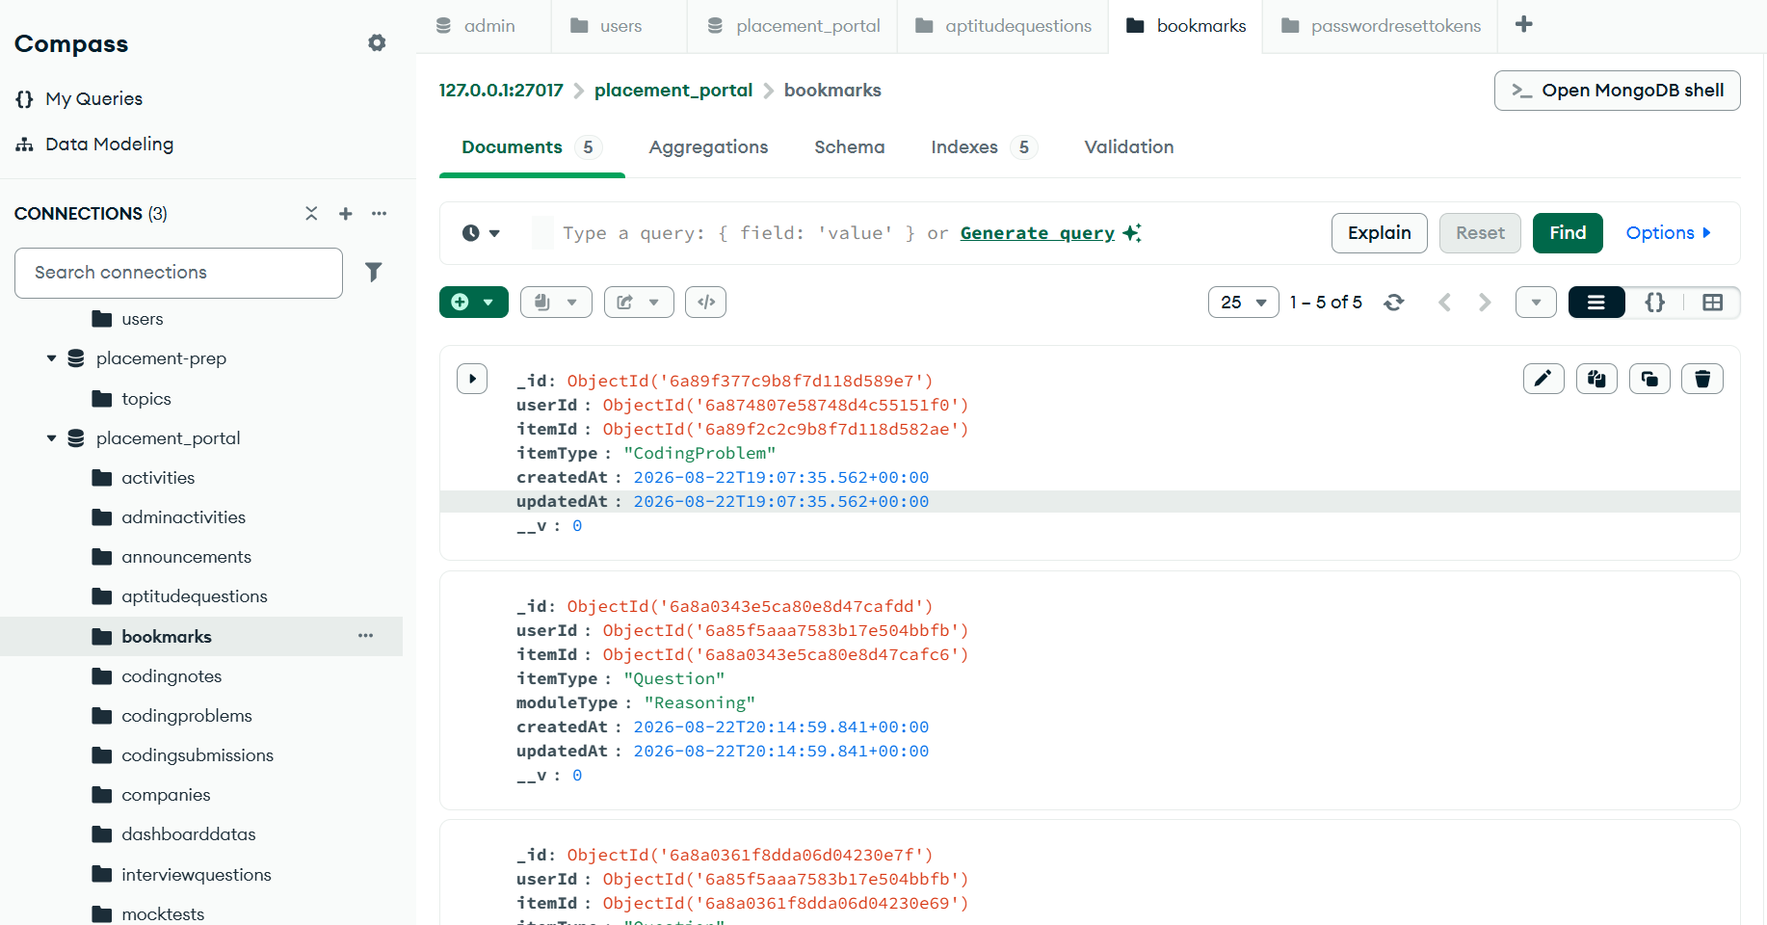
Figure 2.7.4 bookmark
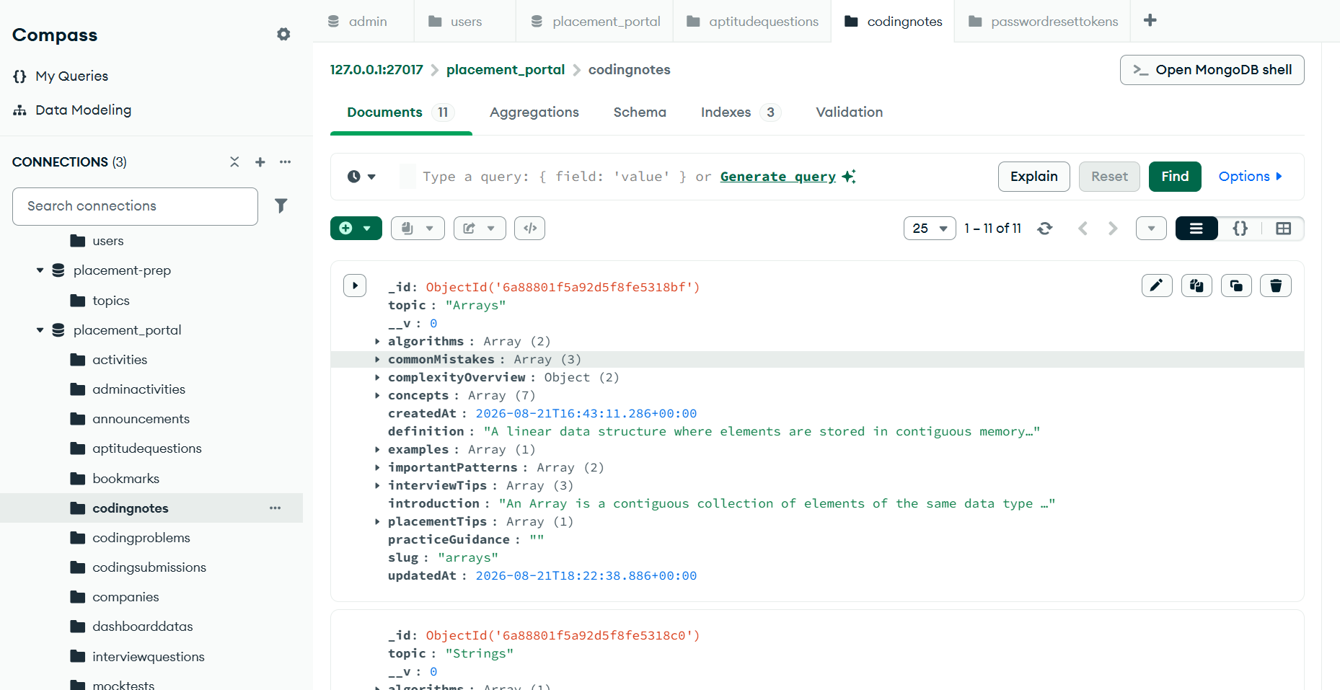
Figure 5.7.5 Codingnotes

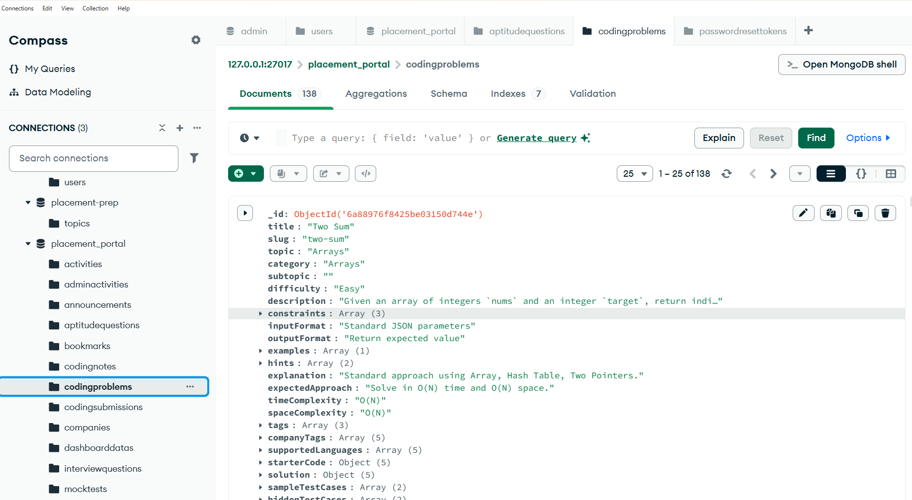
Figure 5.7.6 Codingproblems
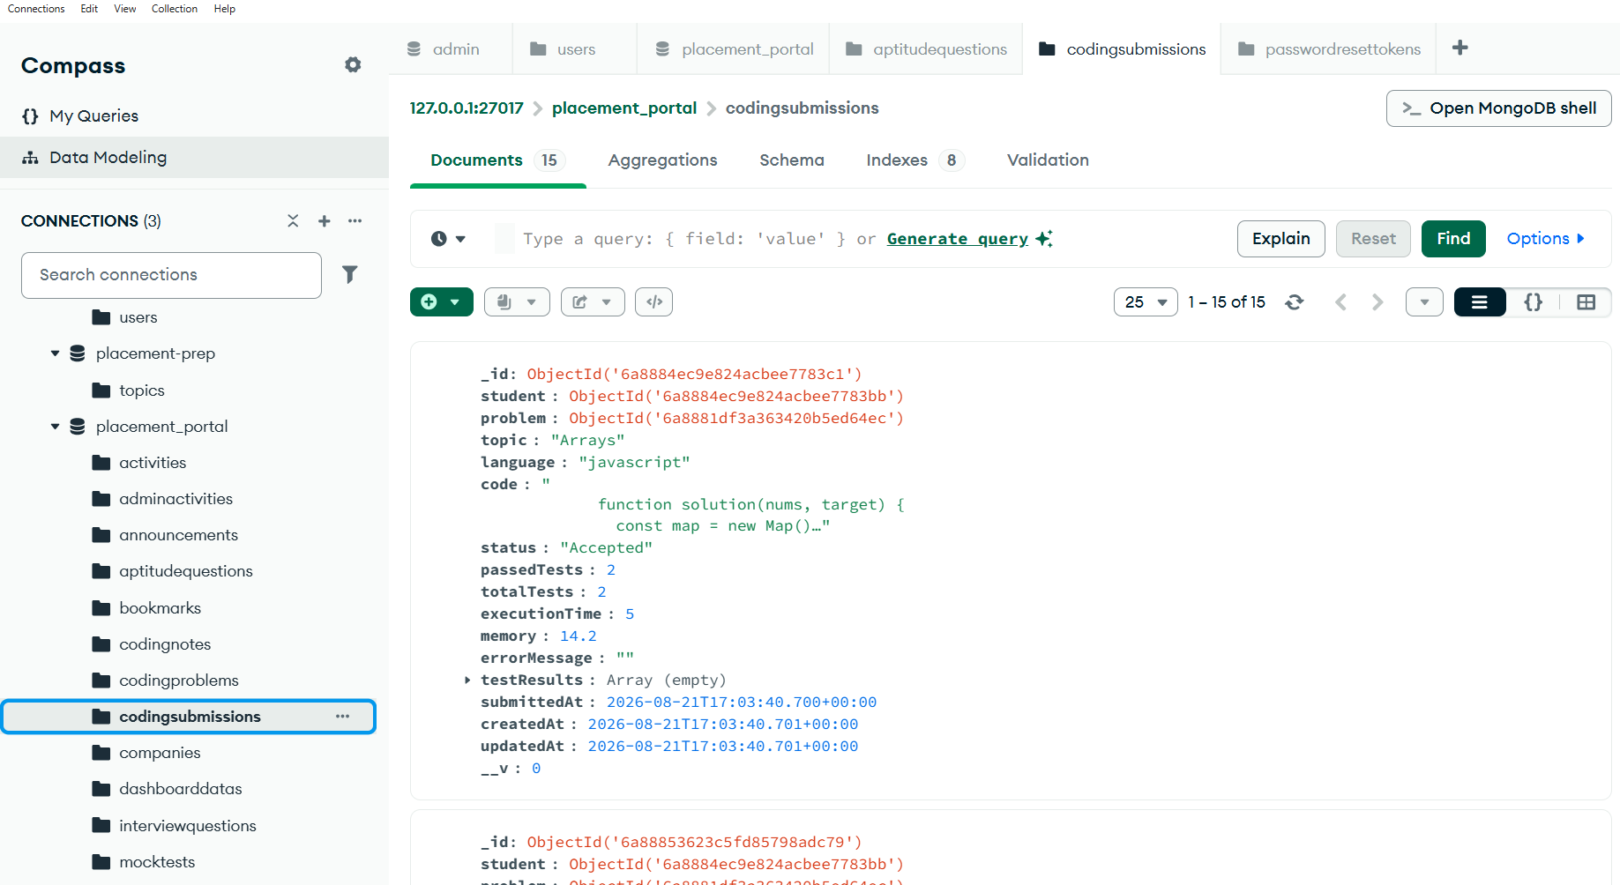
Figure 5.7.7 Codingsubmissiond

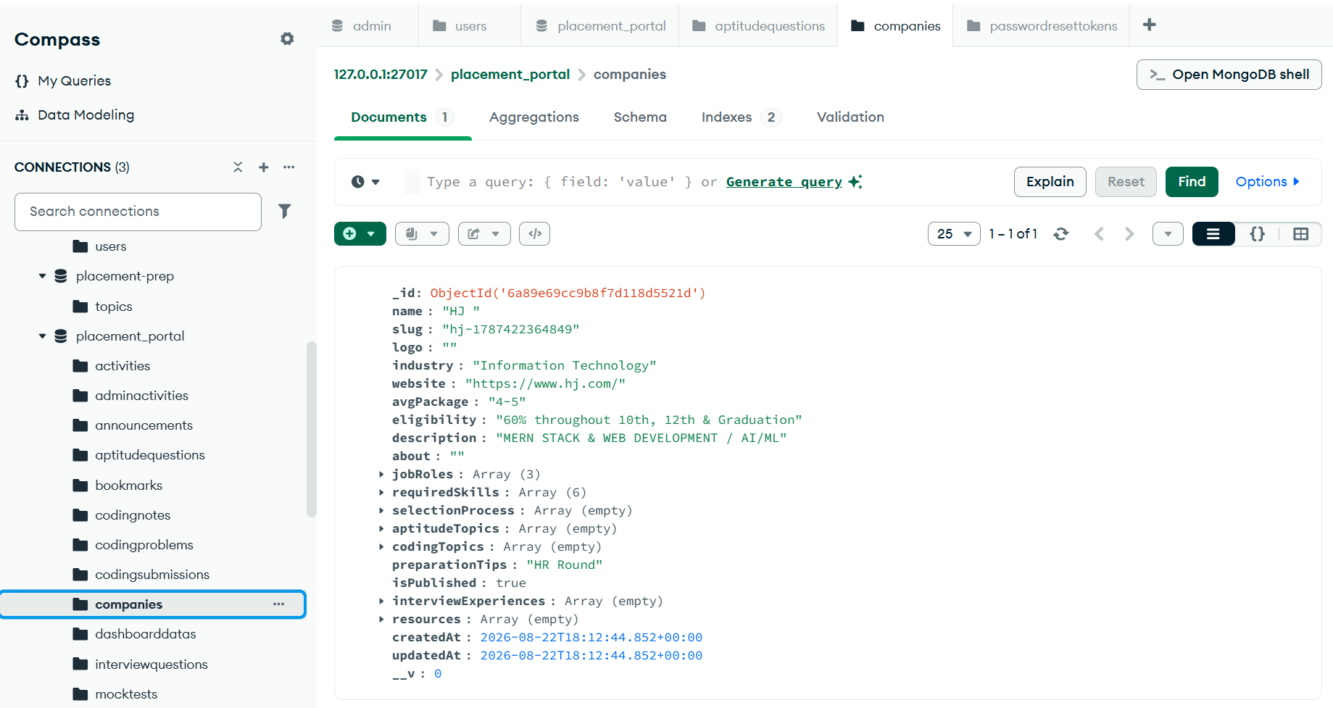
Figure 5.7.8 Companies
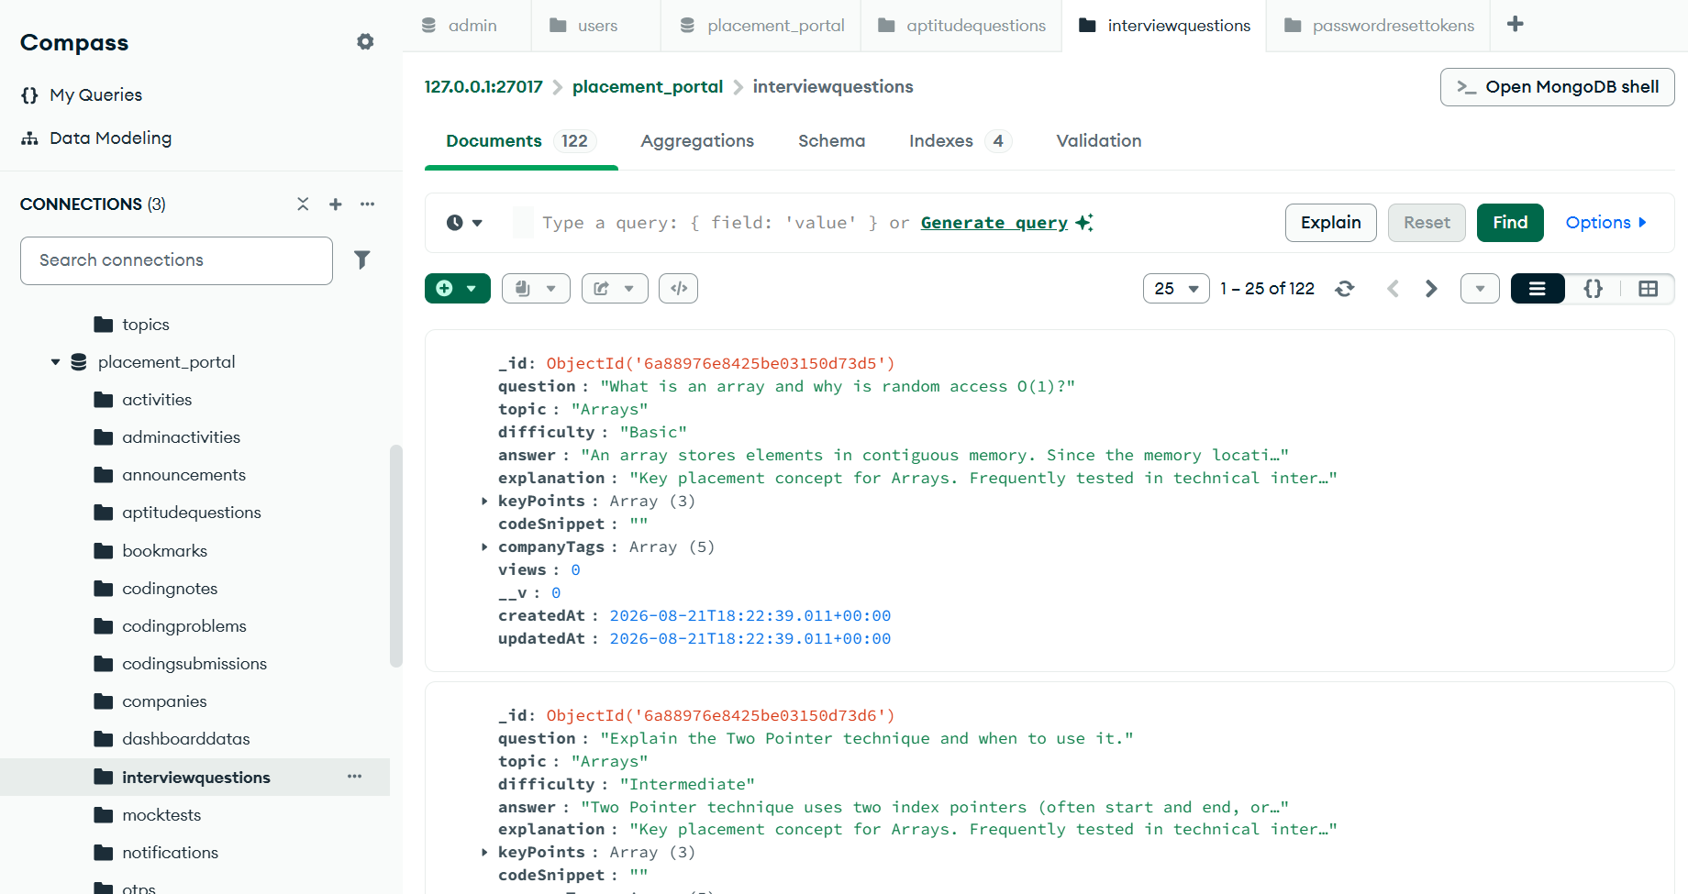
Figure 5.7.9 Interviewqustions

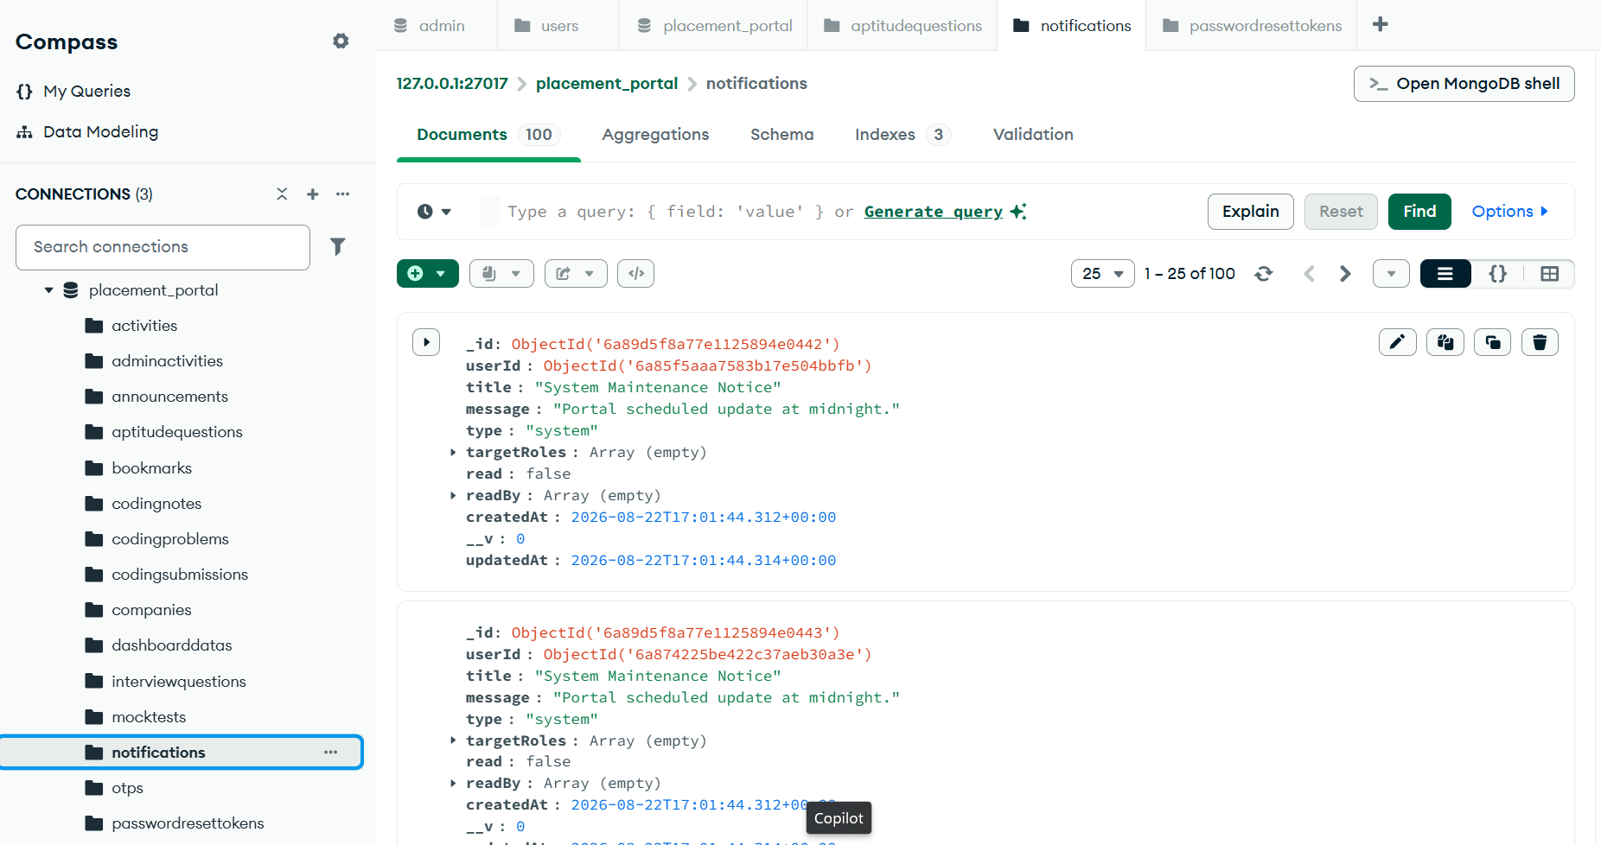
Figure 5.7.10 Notification
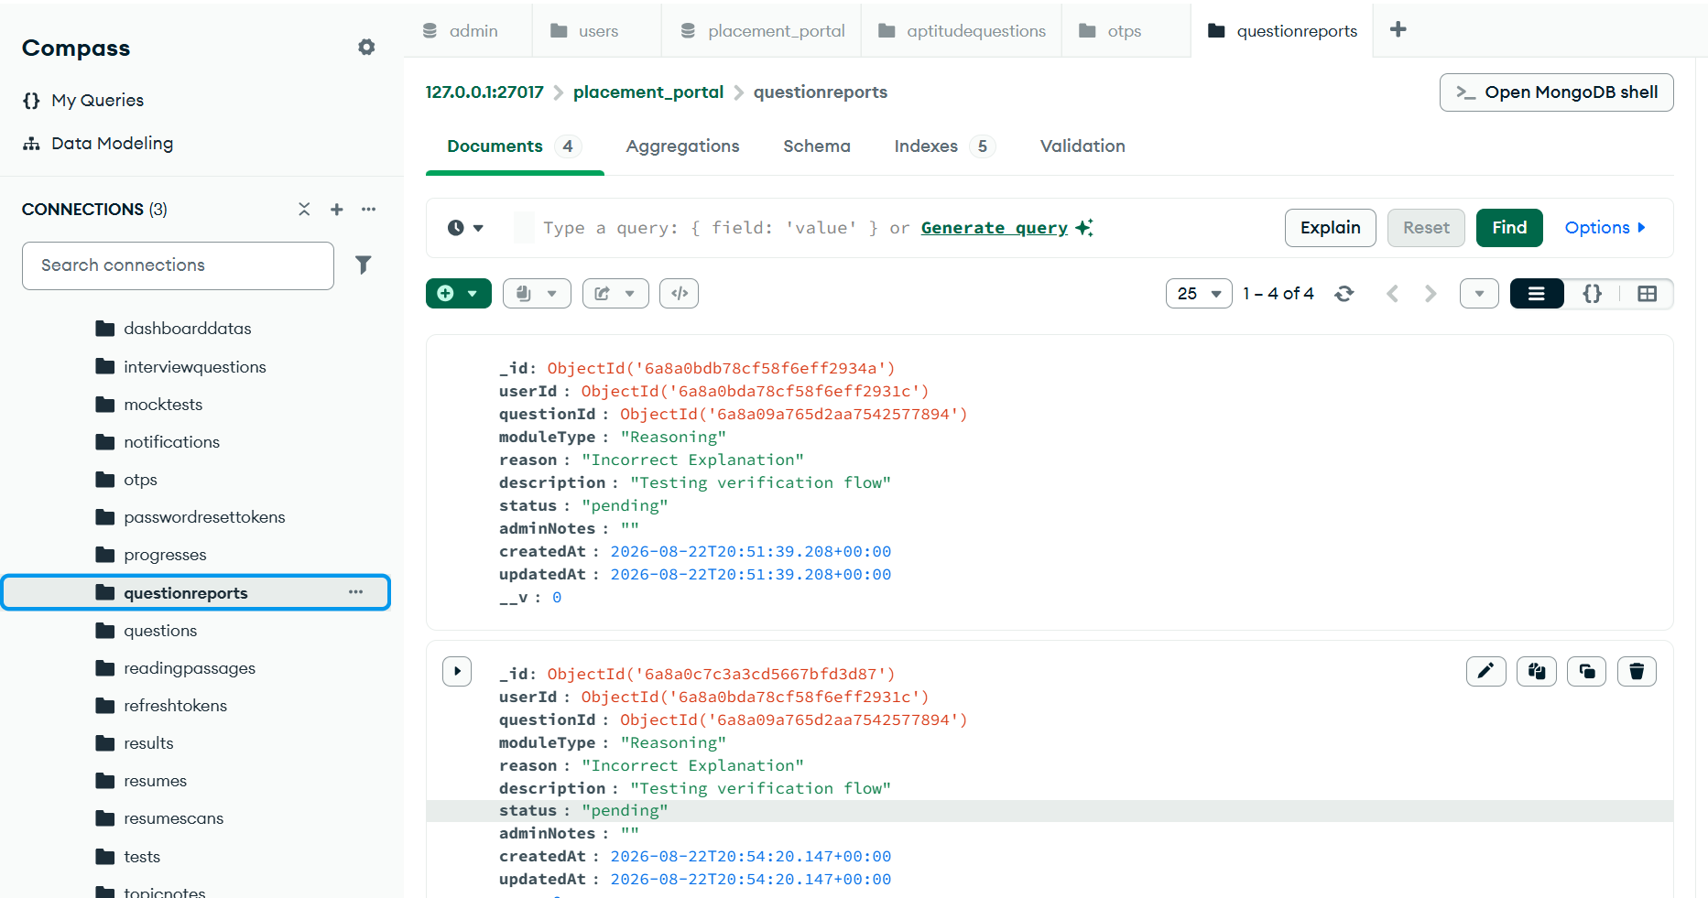

Figure 5.7.11 Question Report

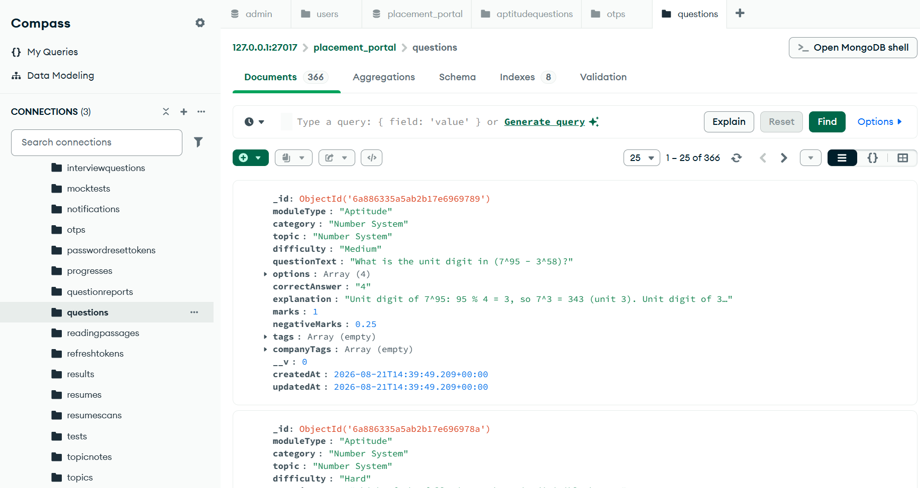
Figure 5.7.12 Questions
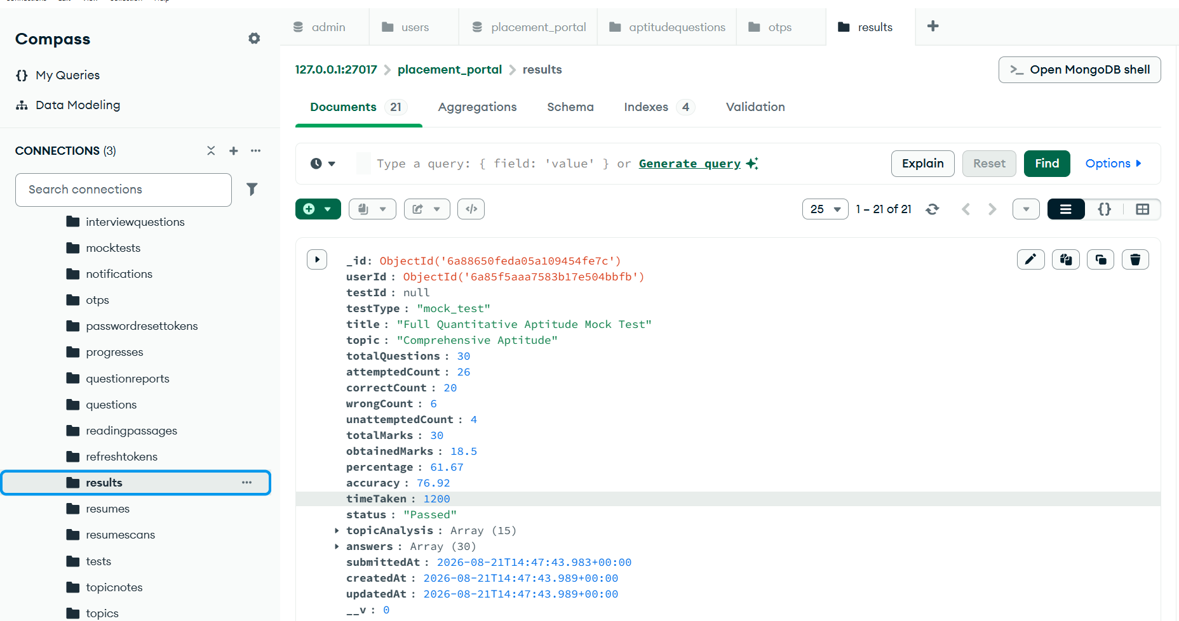
Figure 5.7.13 Result
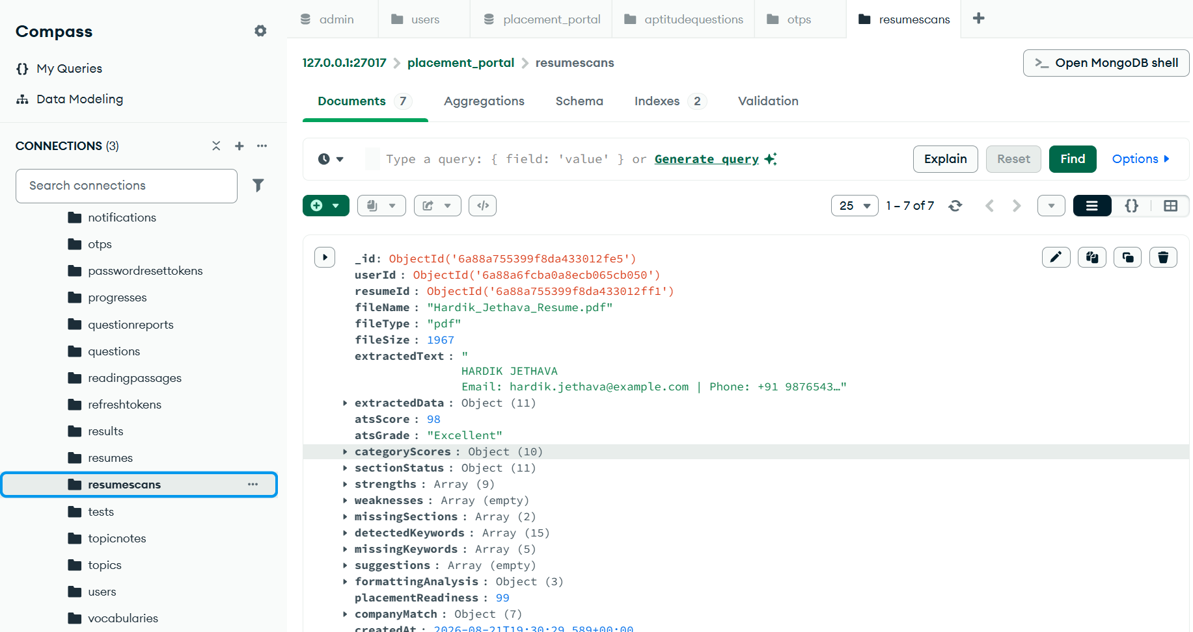
Figure 5.7.14 Resume scans
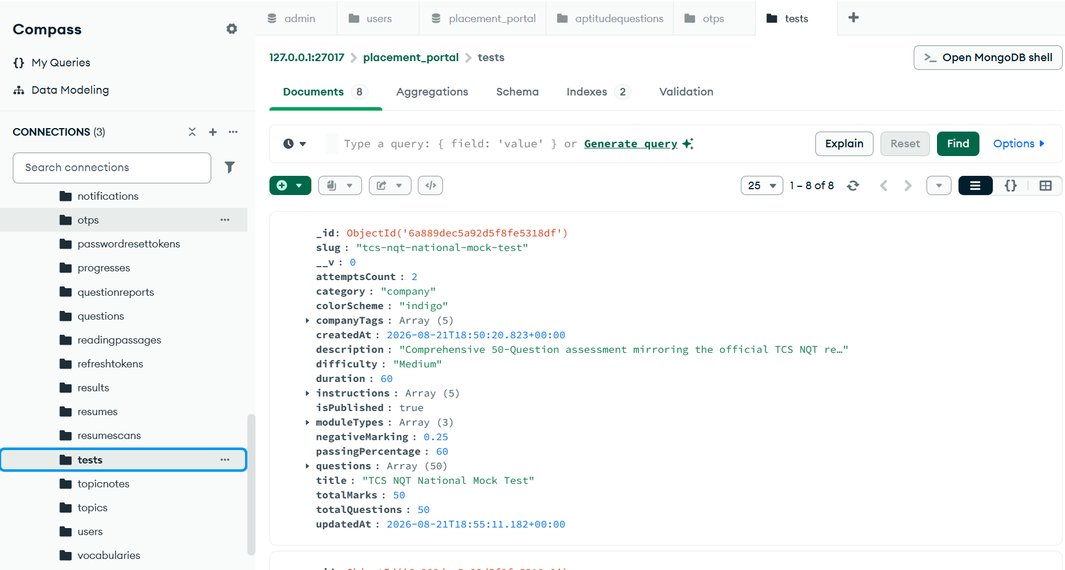
Figure 5.7.15 Test
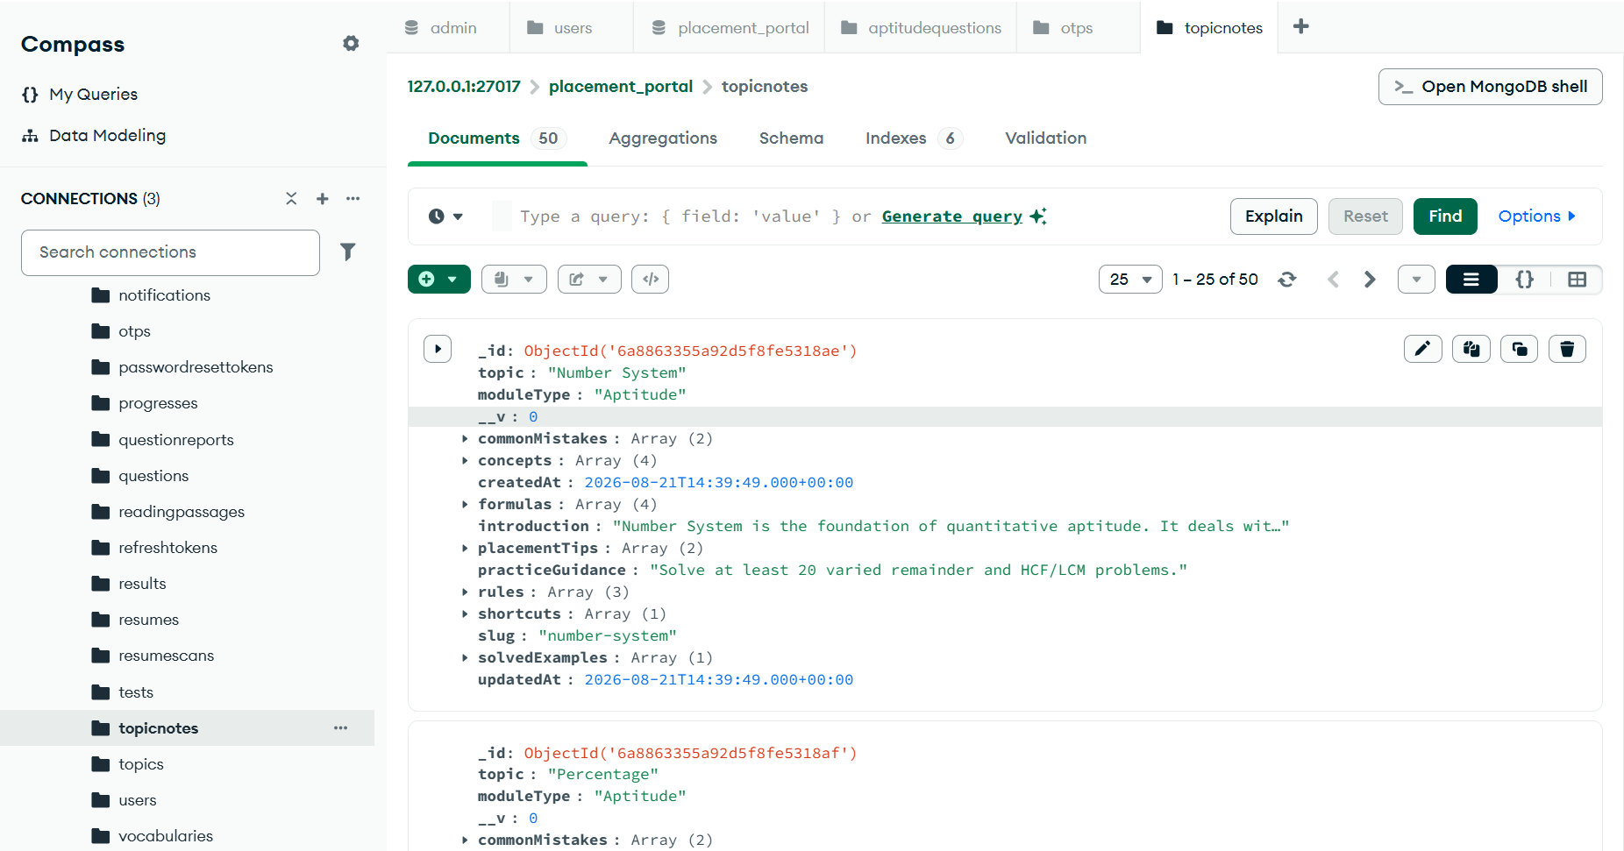
Figure 5.7.16 Topic Notes
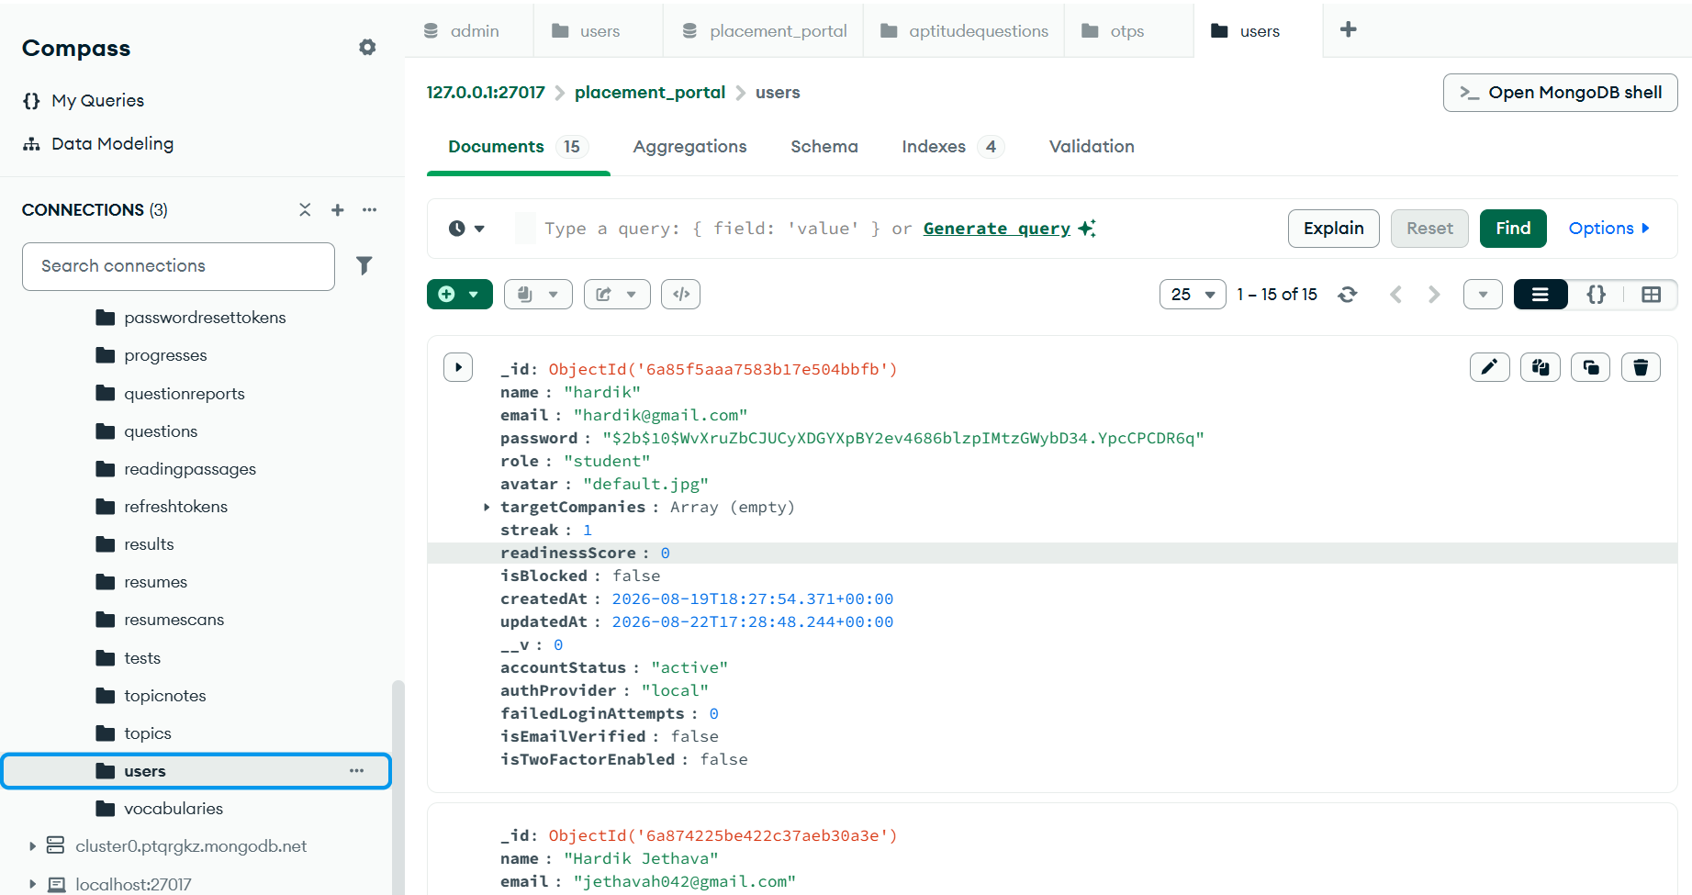
Figure 5.7.17 Users
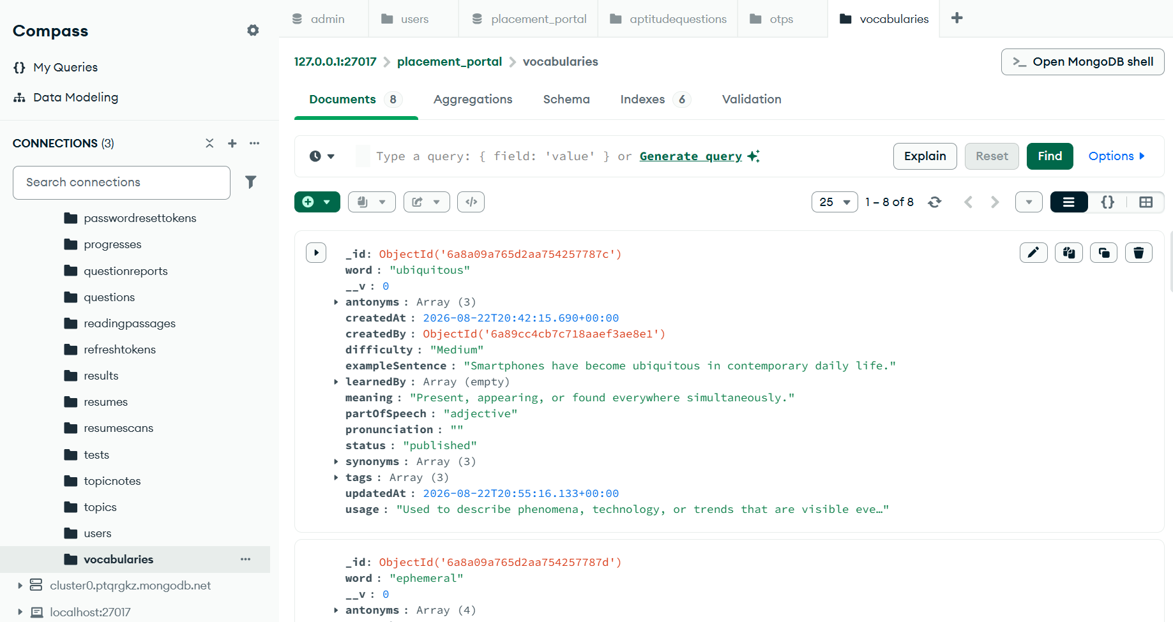
Figure 5.7.18 Vocabulary

5.8 Student Menu-Screen Design:

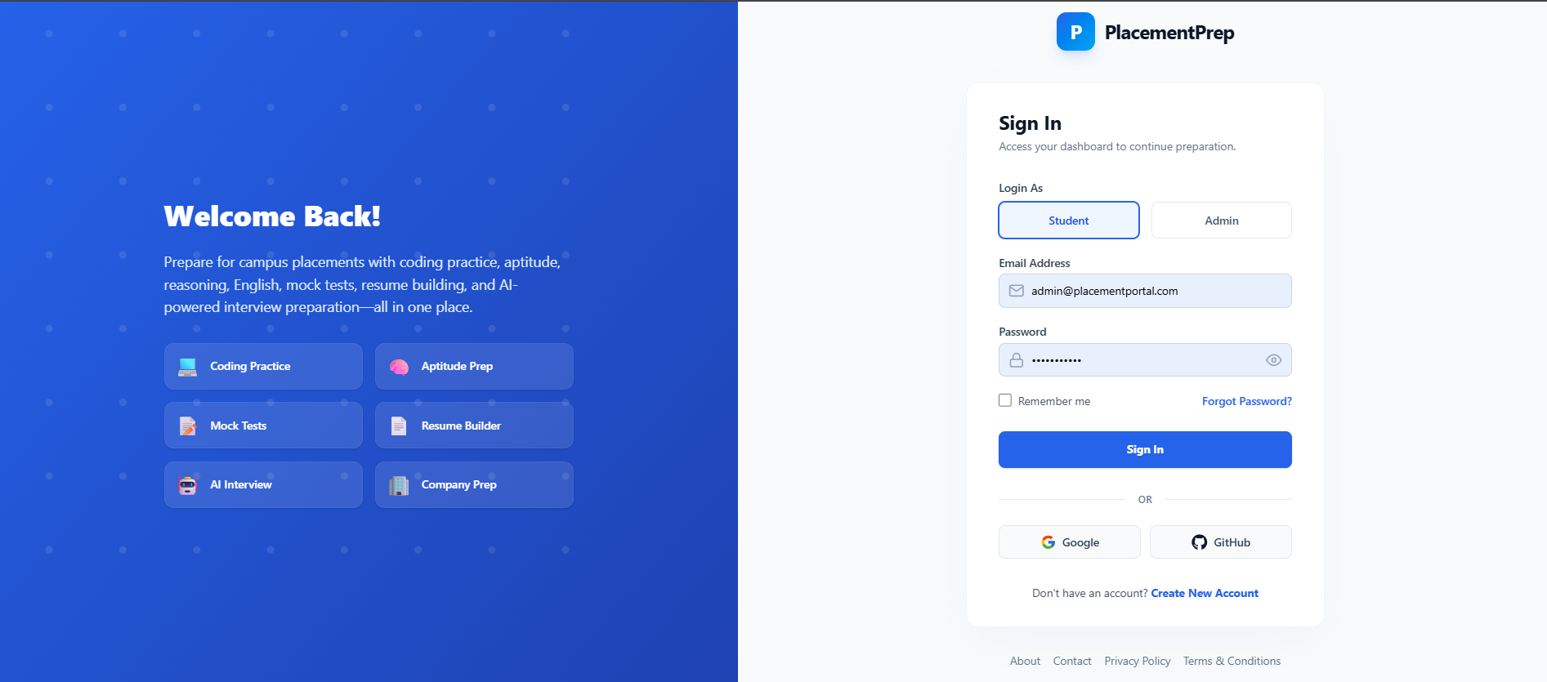
Figure 5.8.1 Student Login Screen

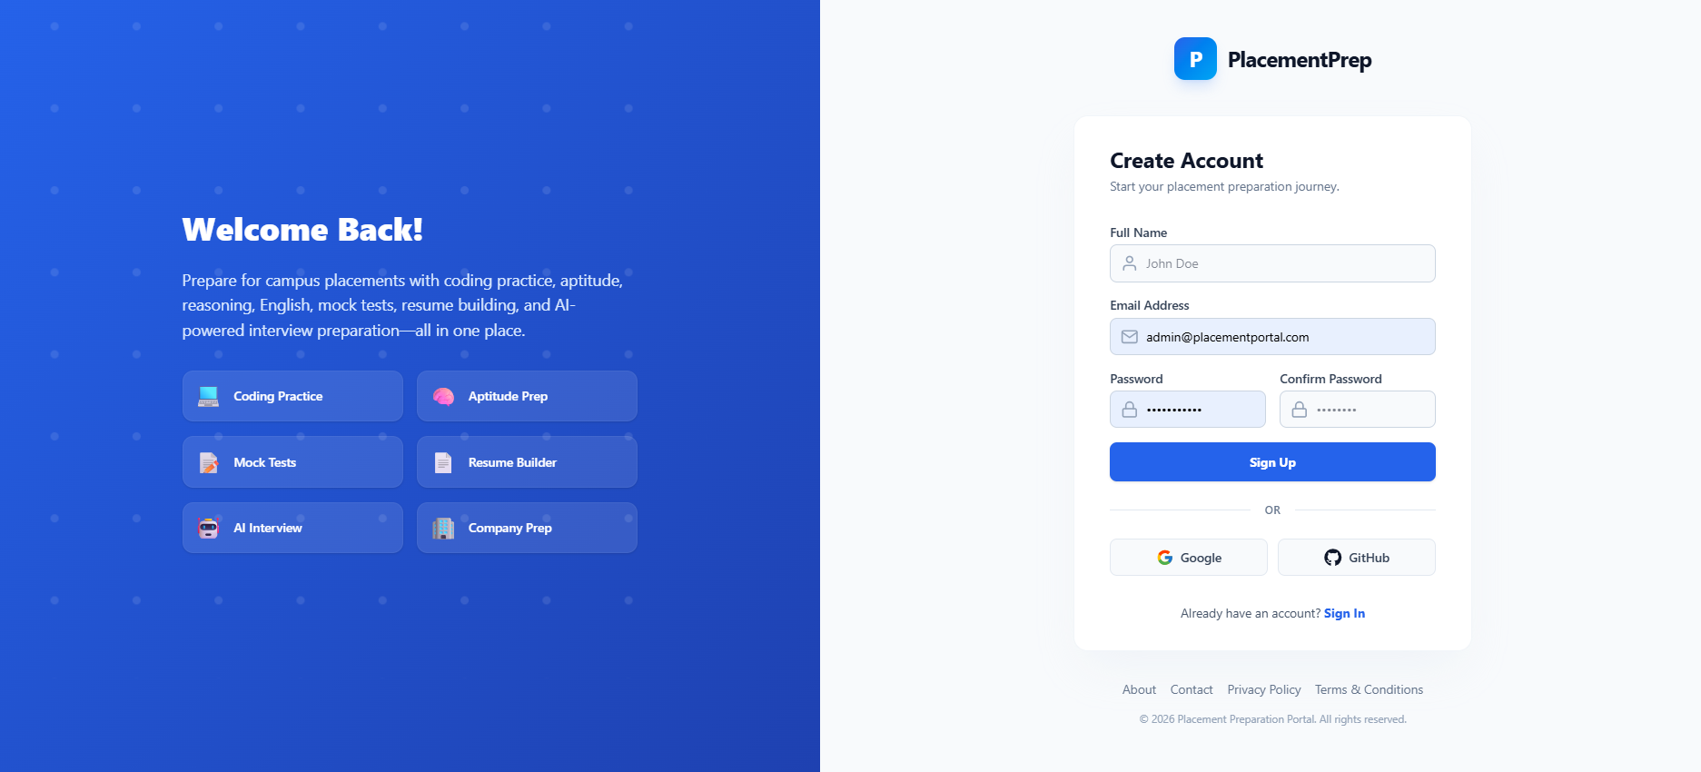
Figure 5.8.2 Student Register Screen

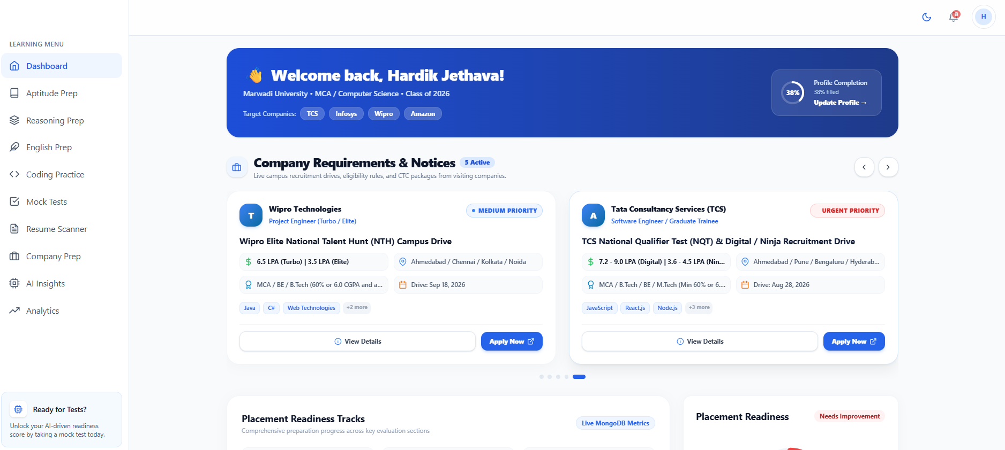
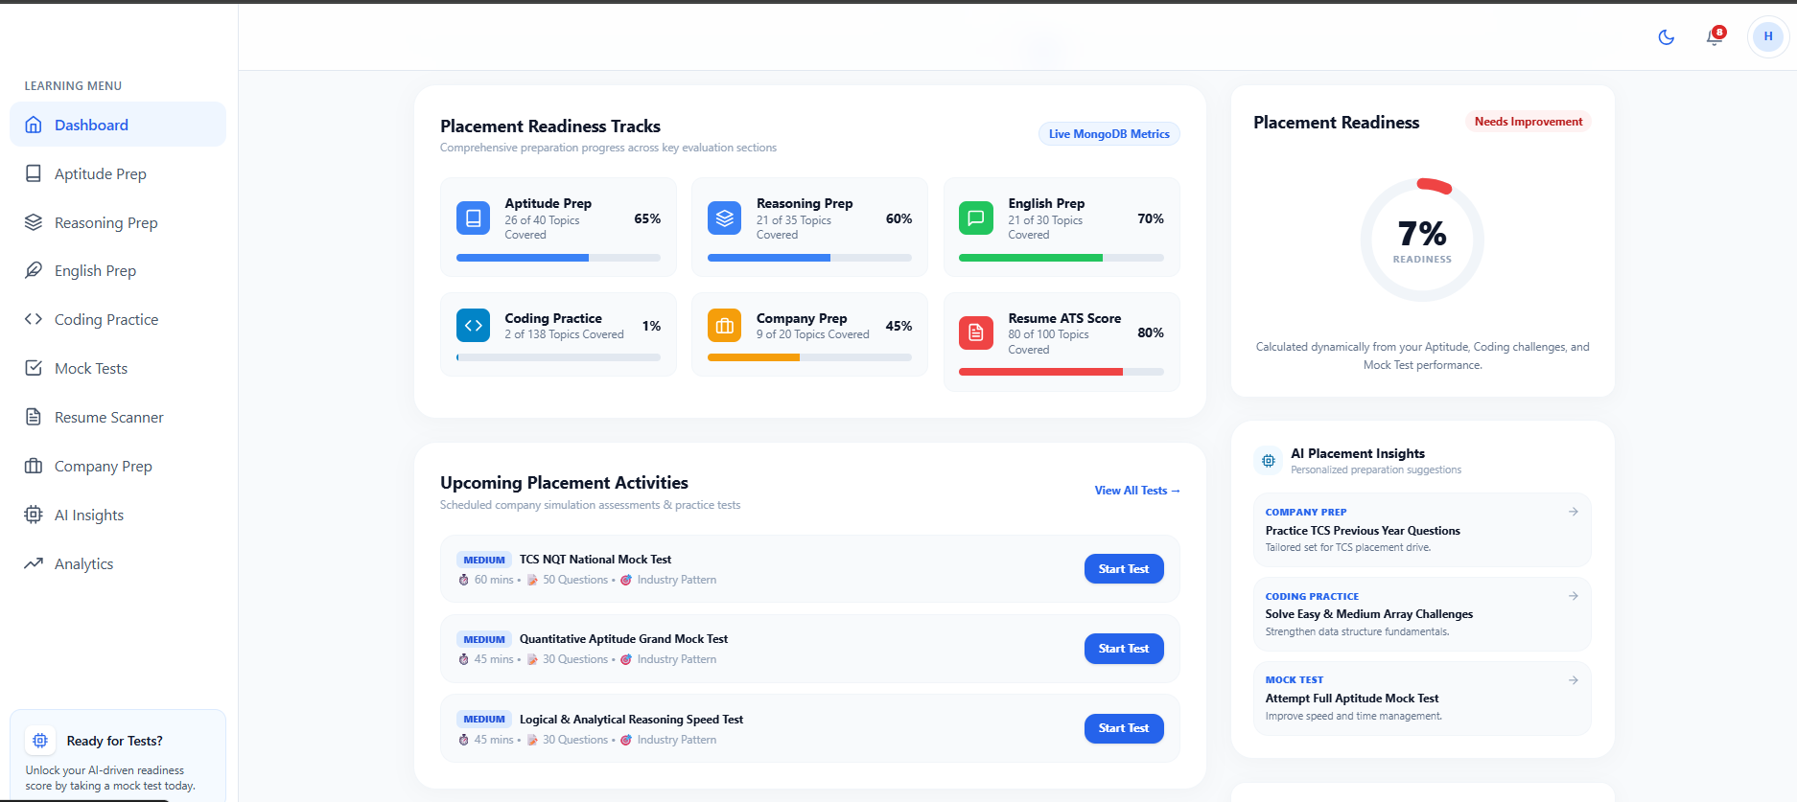

Figure 3.8.3 Student Dashboard Screen
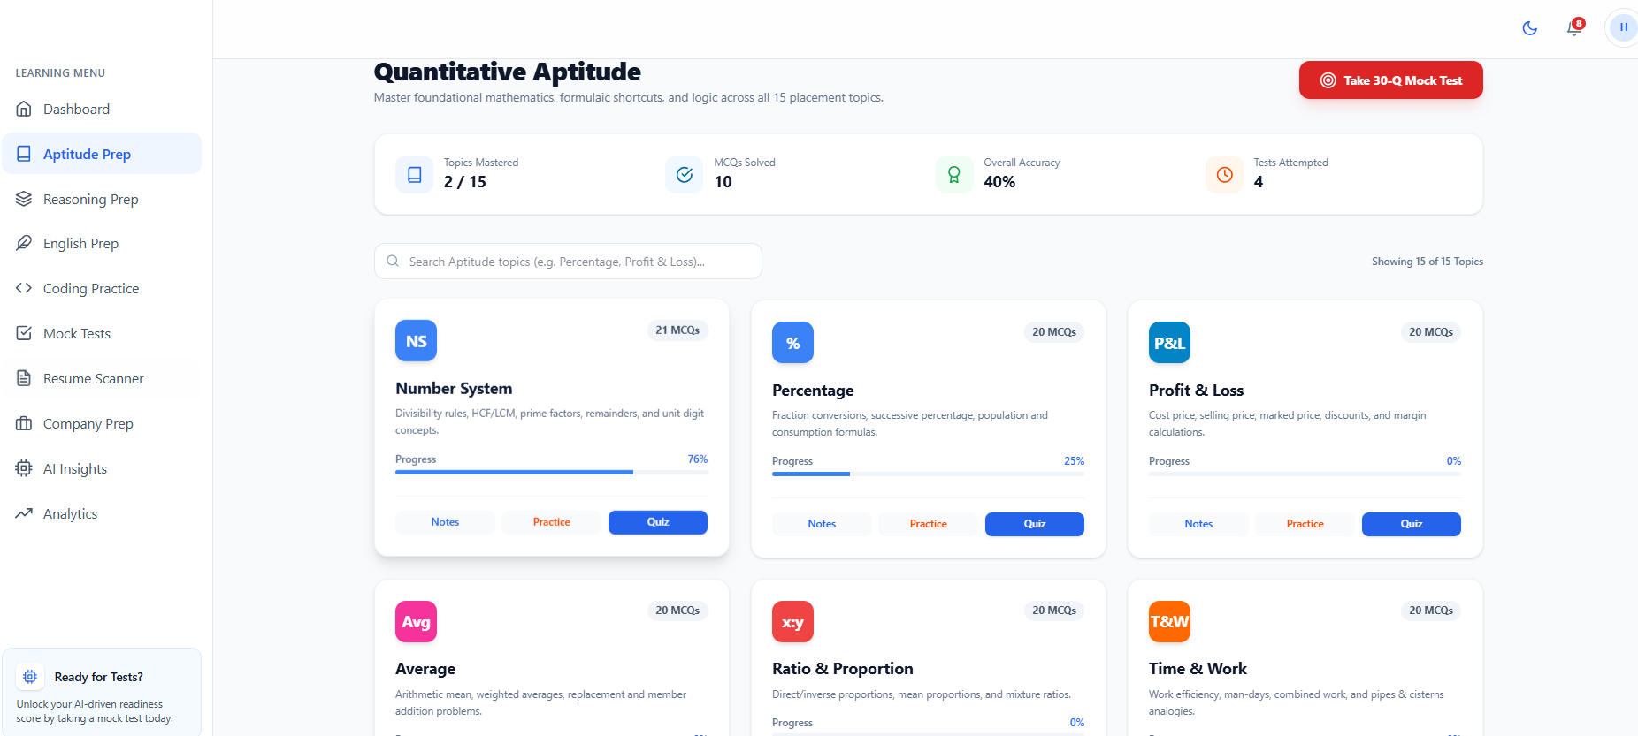
Figure 5.8.4 Aptitude Pre

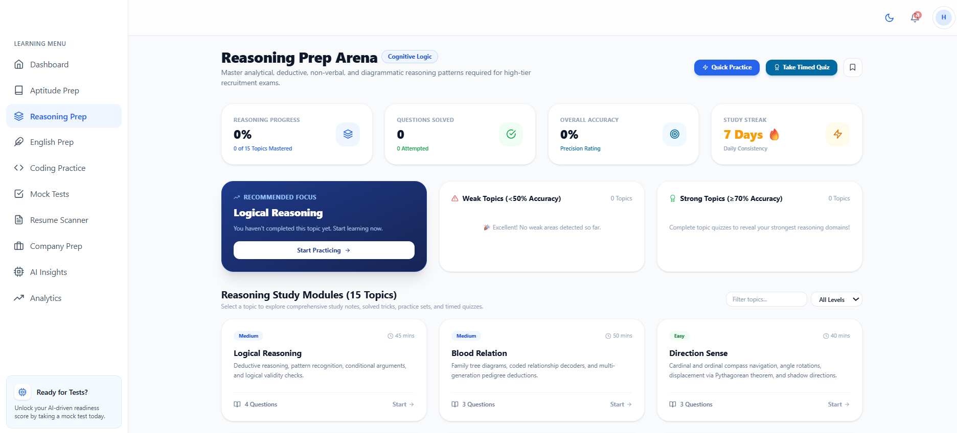
Figure 5.8.5 Reasoning Pre

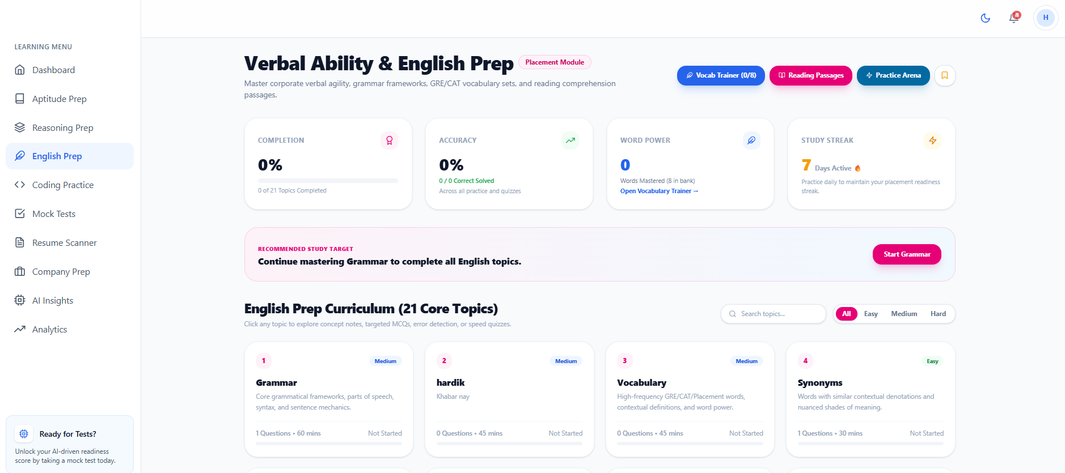
Figure 5.8.6 verbal Ability & English Pre
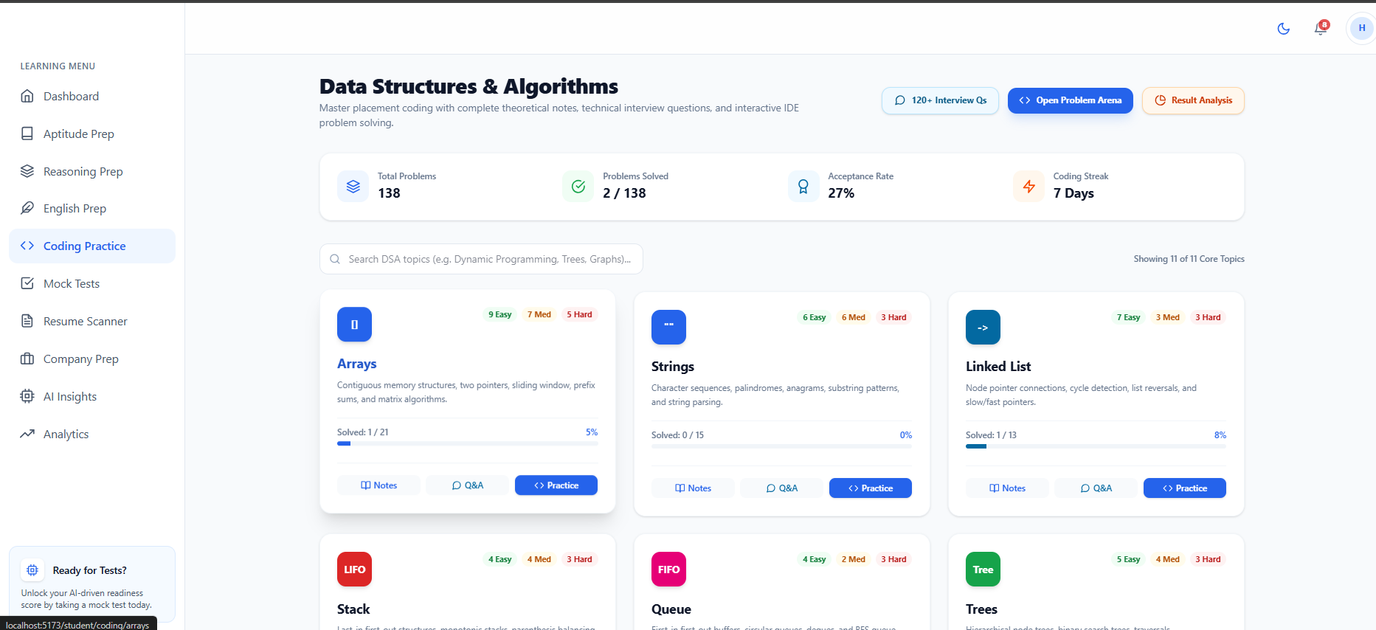
Figure 5.8.7 Coding Practise

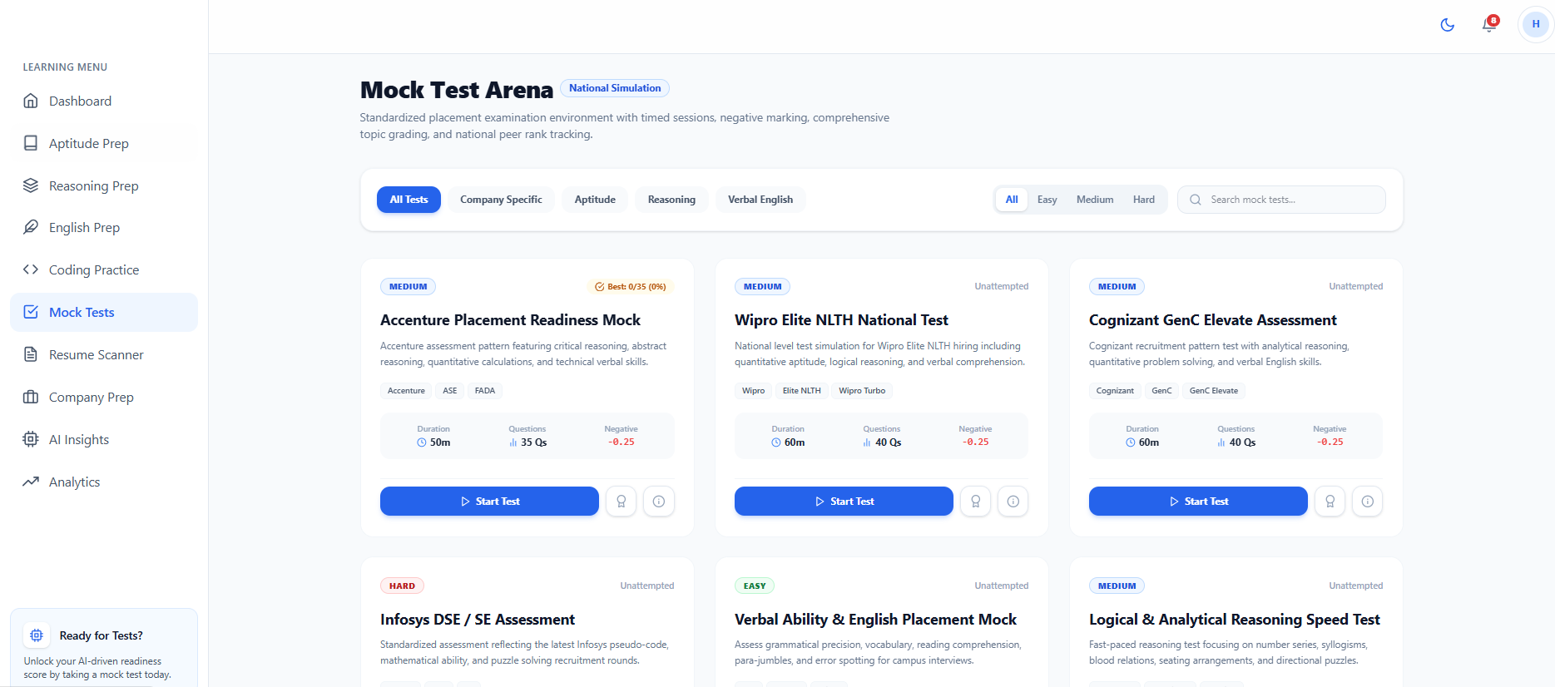
Figure 5.8.8 Mock Test
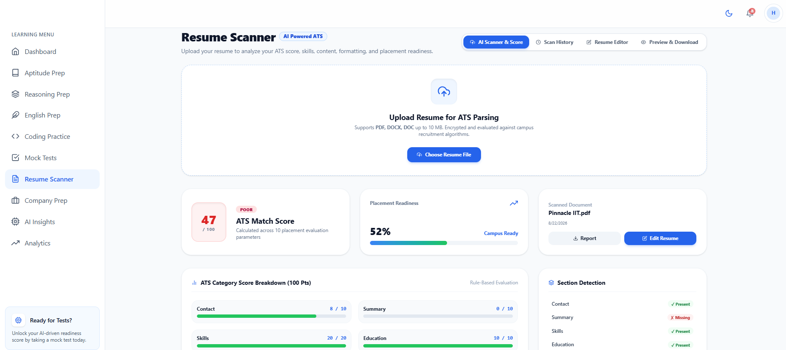
Figure 5.8.9 Resume Scanning

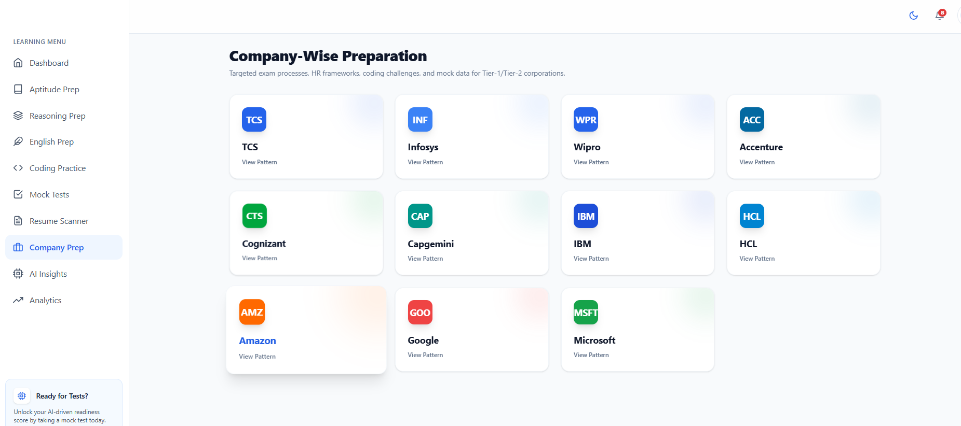
Figure 5.8.10 Company Preparation 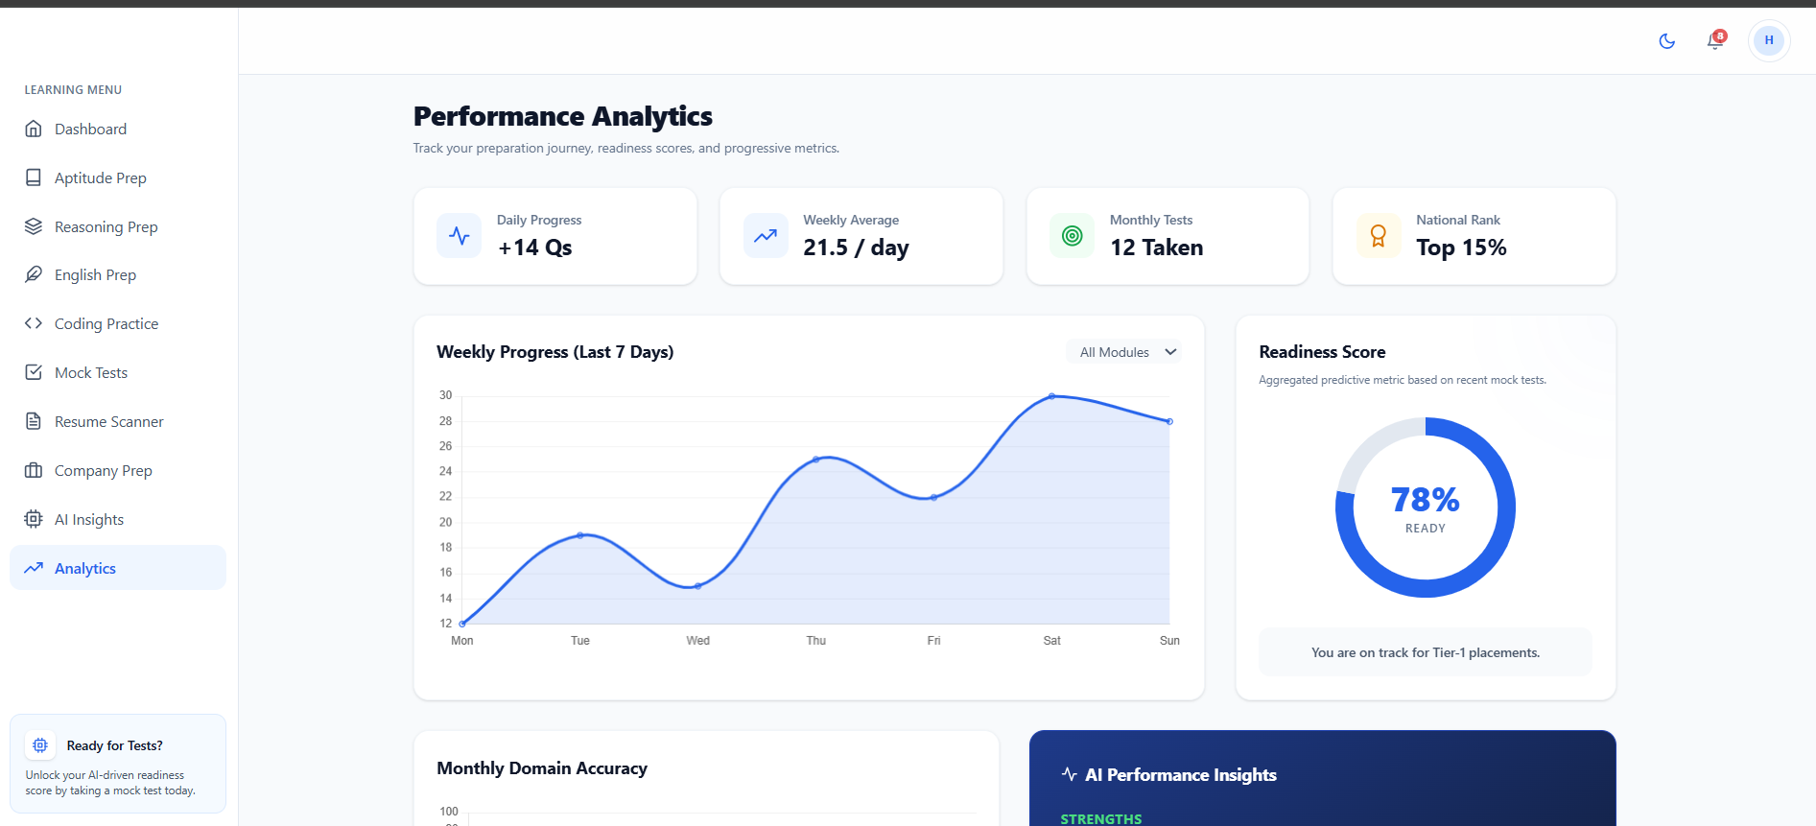
Figure 5.8.11 Performance Analysis

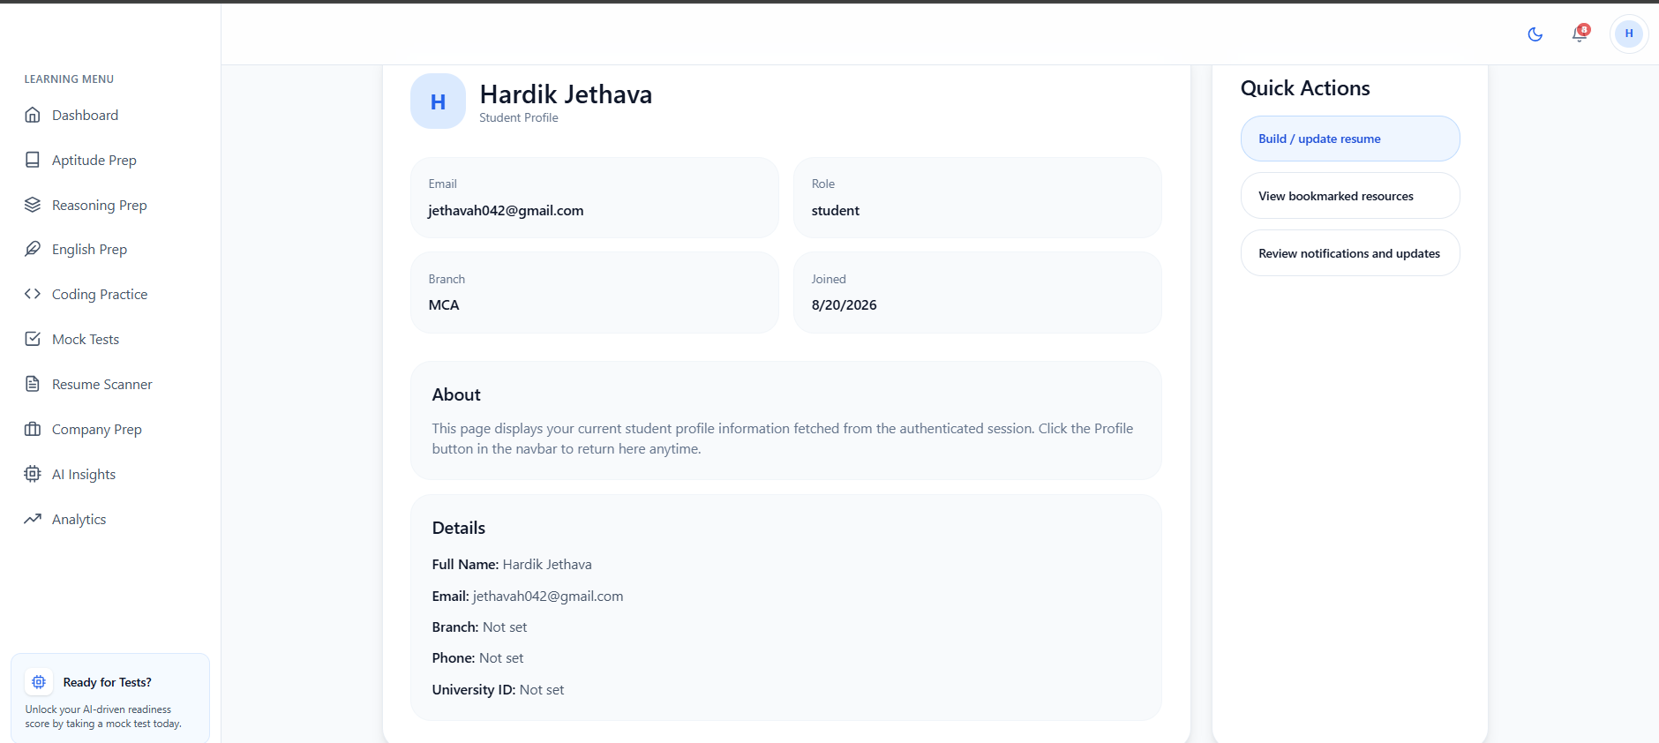
Figure 5.8.12 Student Profiles

5.9 Admin Menu-Screen Design:

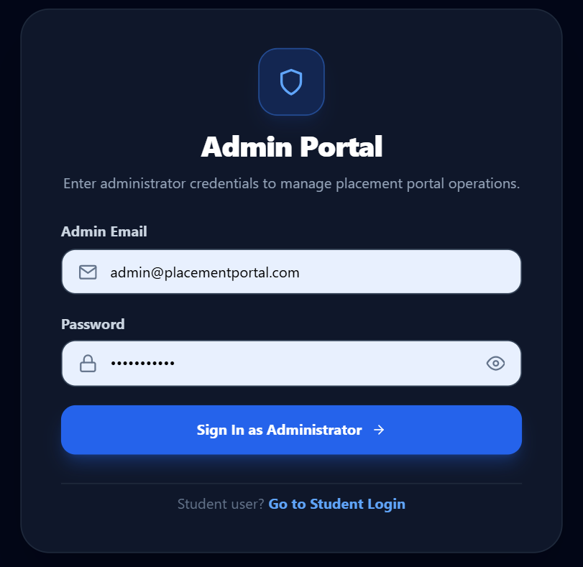
Figure 5.9.1 Admin Login

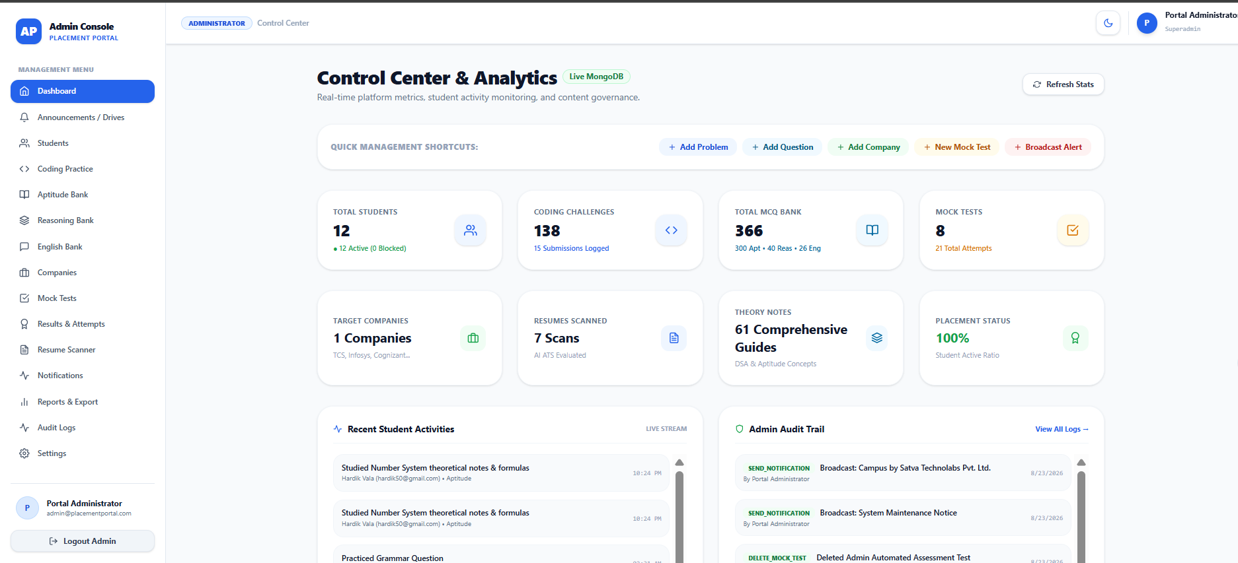
Figure 5.9.2 Admin Dashboard

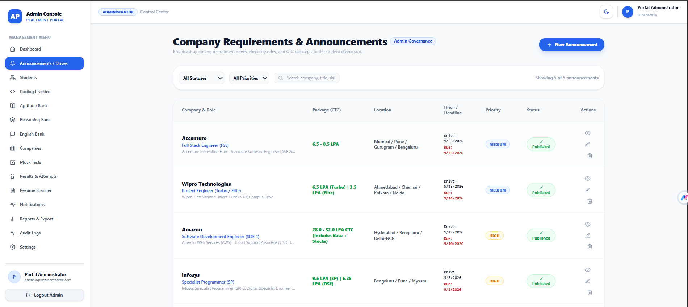
Figure 5.9.3 Announcement
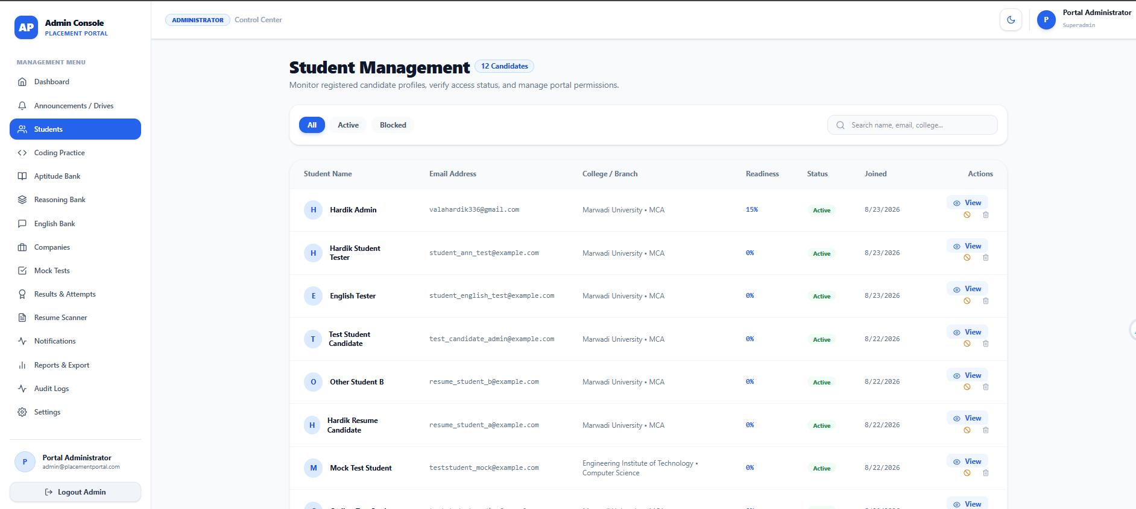
Figure 5.9.4 Student Management

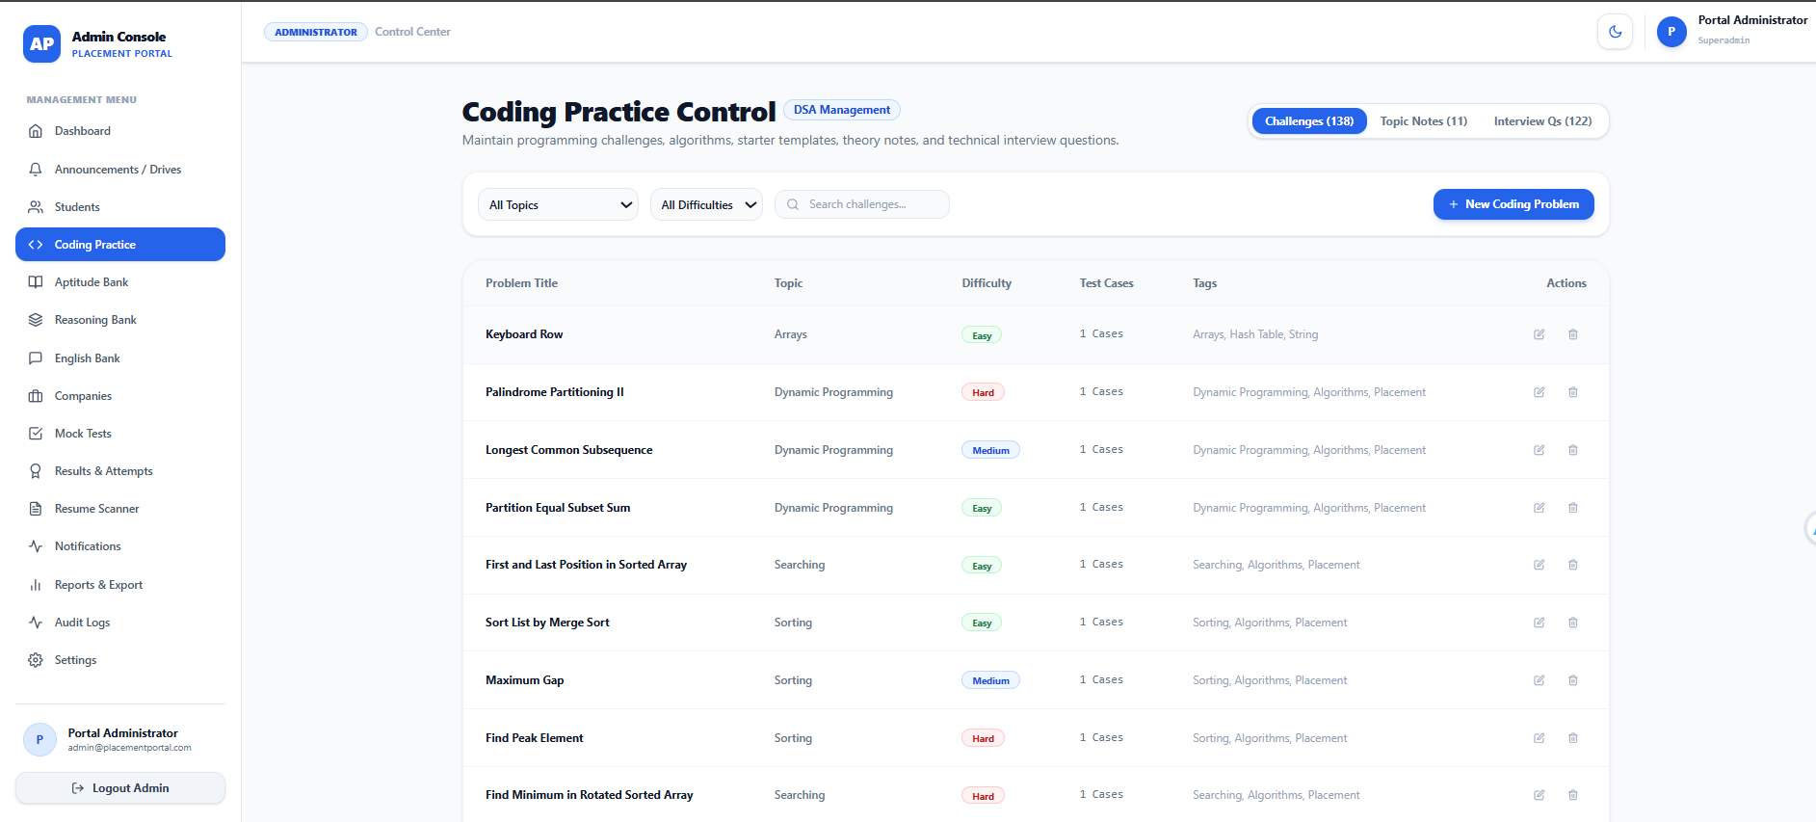
Figure 5.9.5 Coding Practise

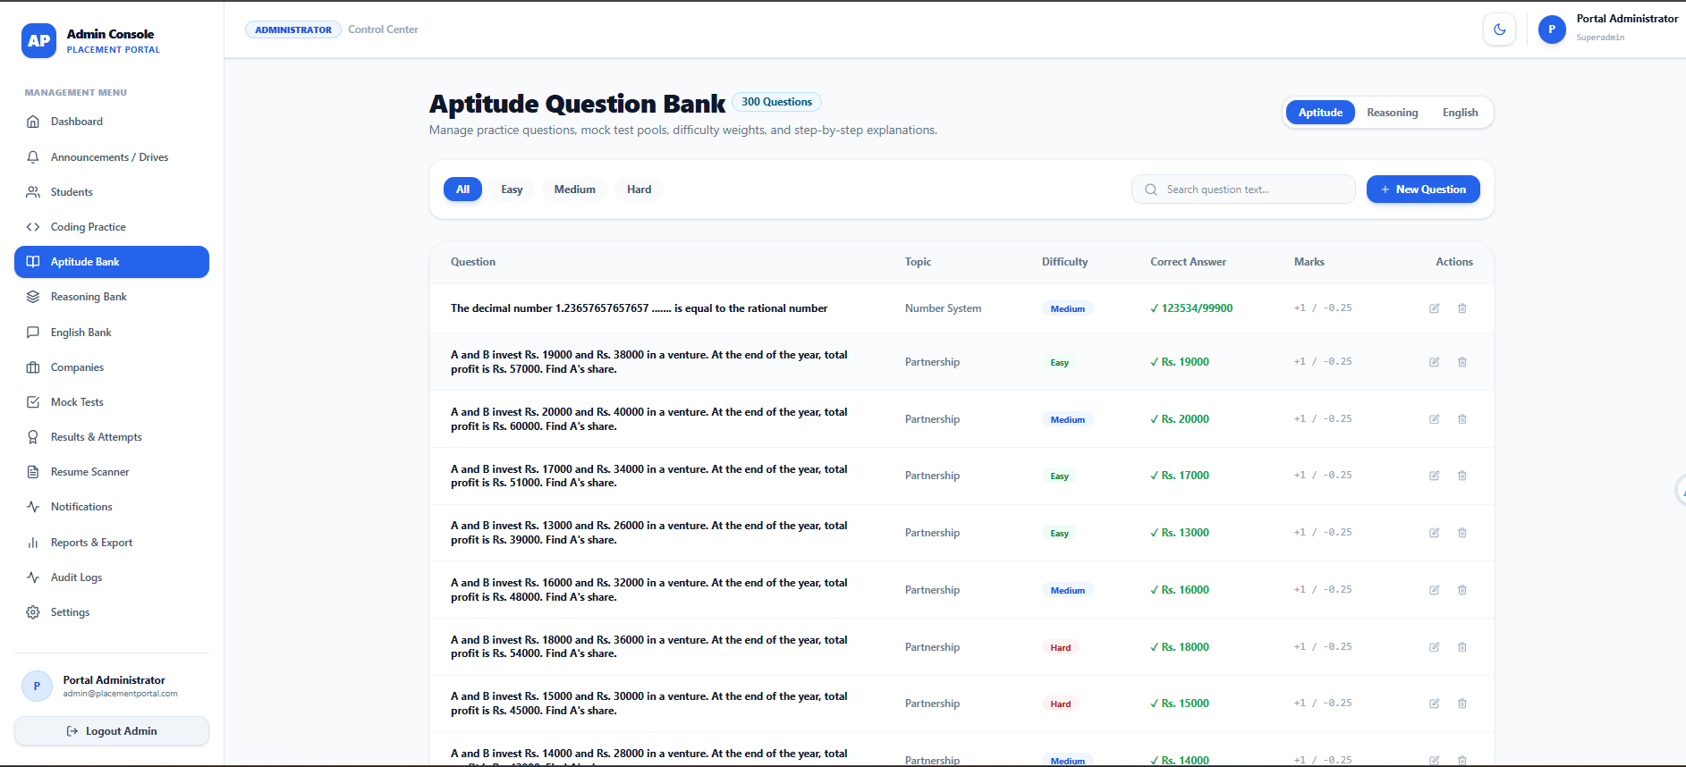
Figure 5.9.6 Aptitude Bank

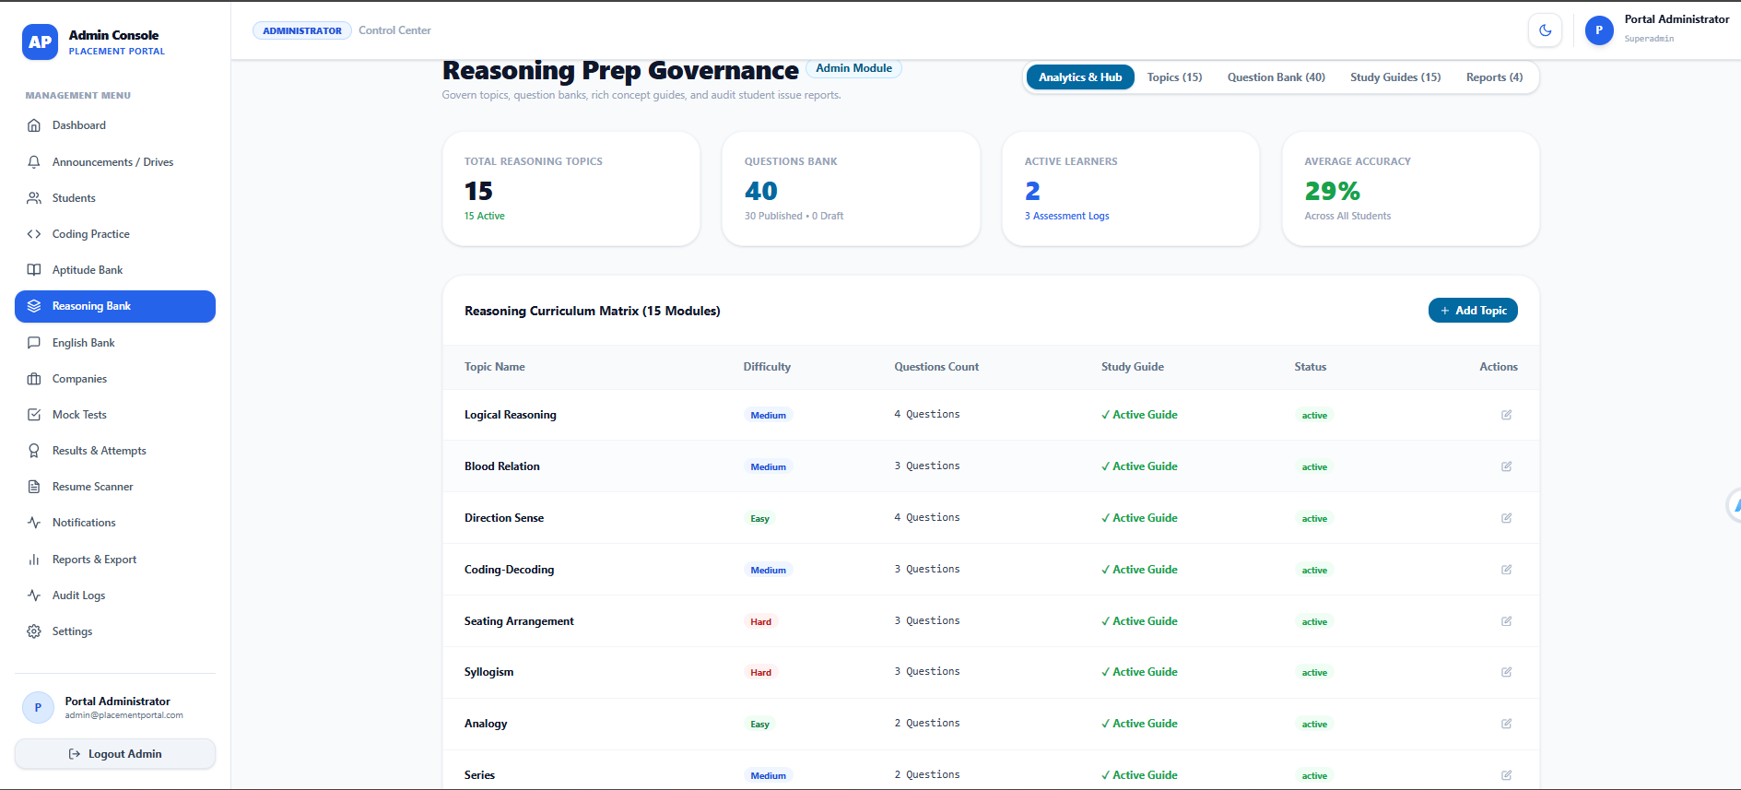
Figure 5.9.7 Reasoning Bank
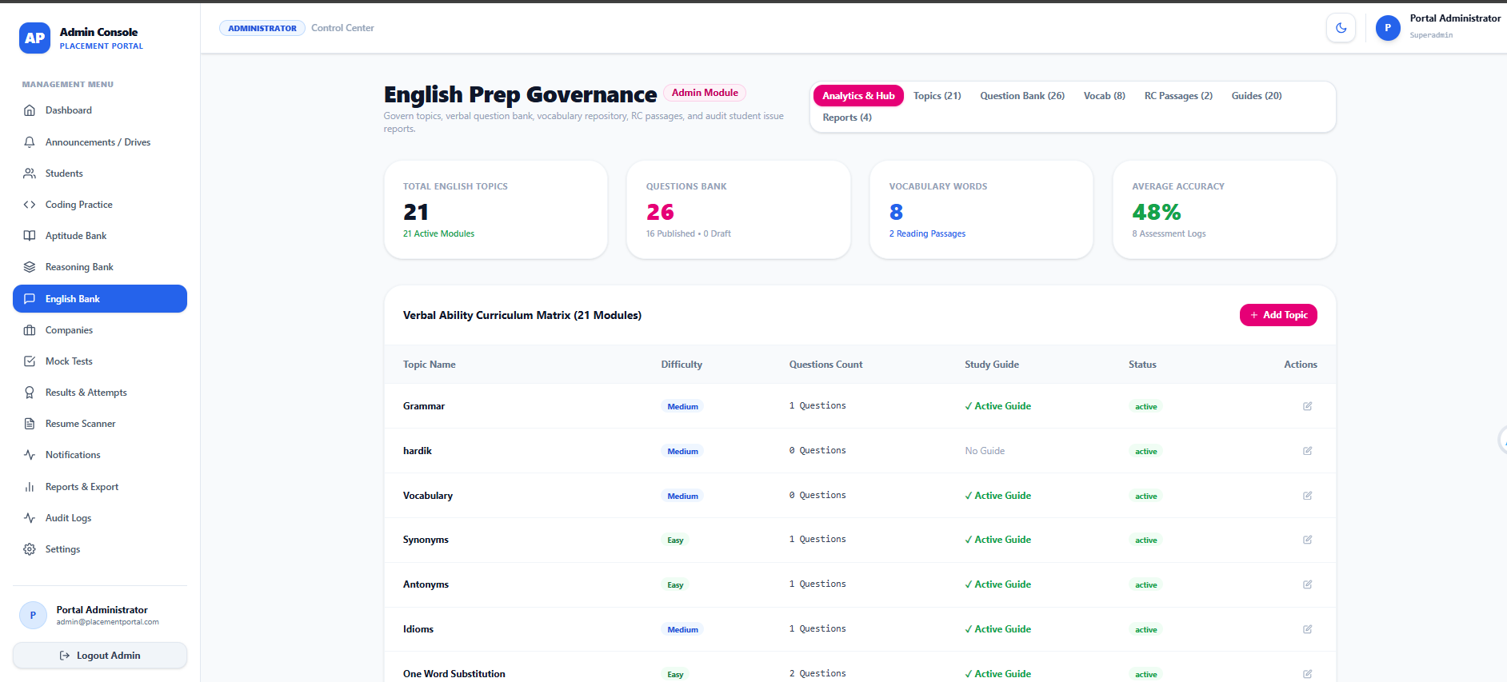
Figure 5.9.8 English Bank

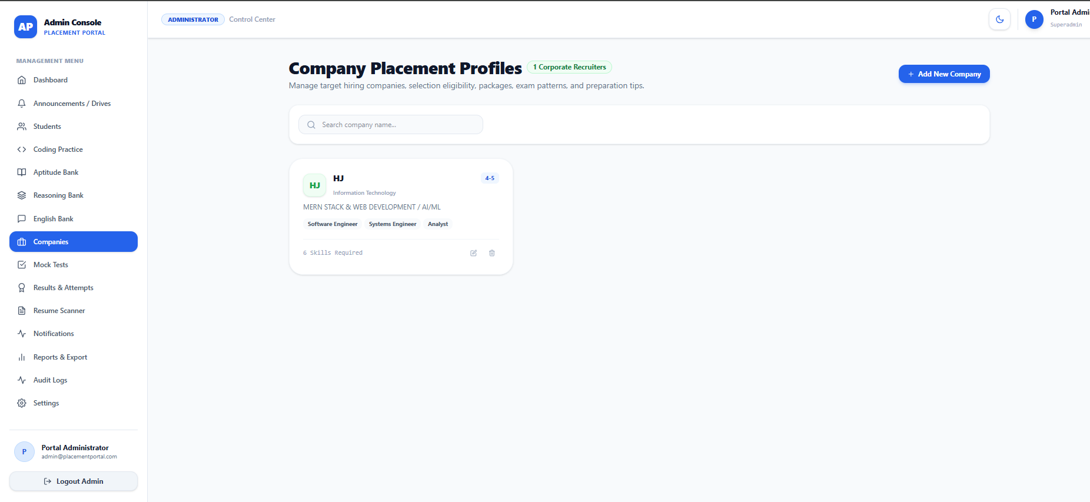
Figure 5.9.9 Companies
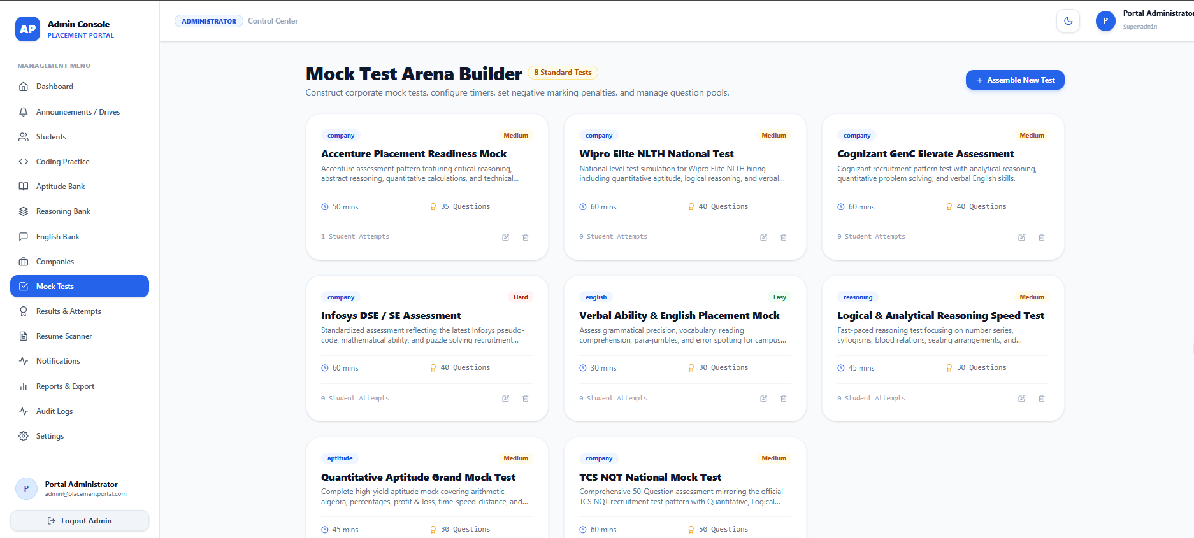
Figure 5.9.10 Mock Test
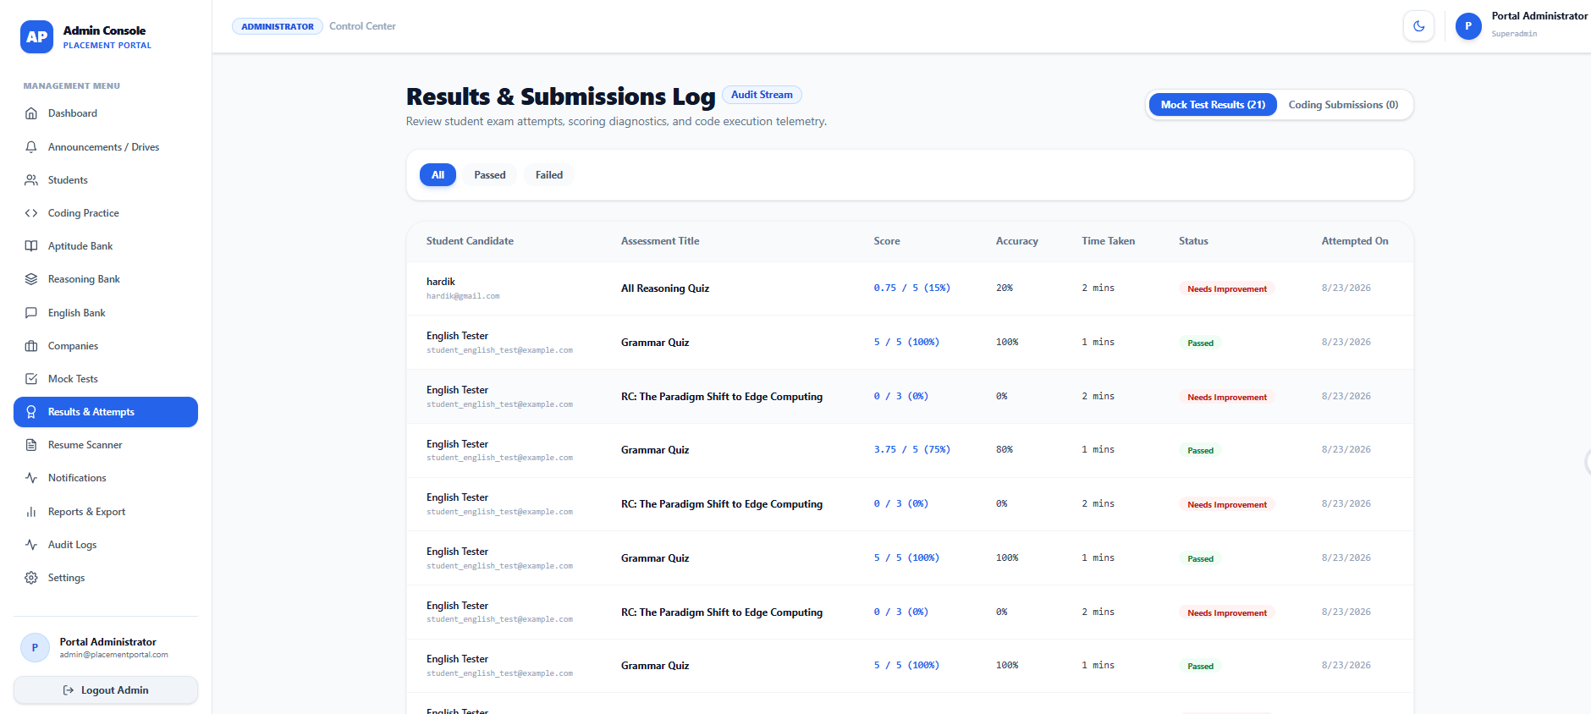
Figure 5.9.11 Results & Attempt
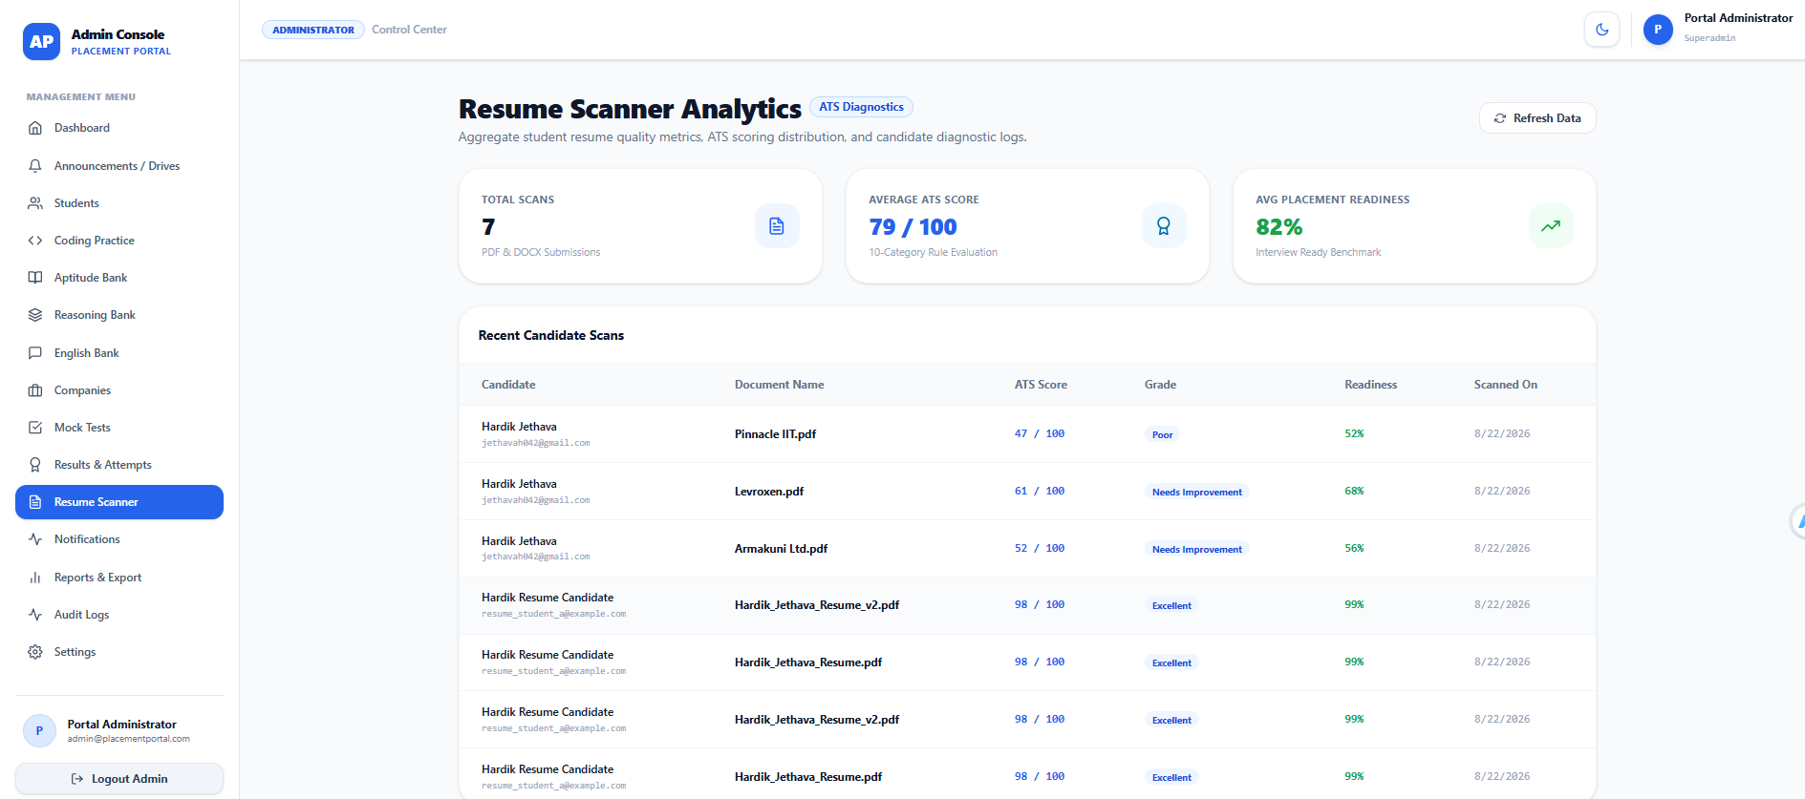
Figure 5.9.12 Resume Scanning
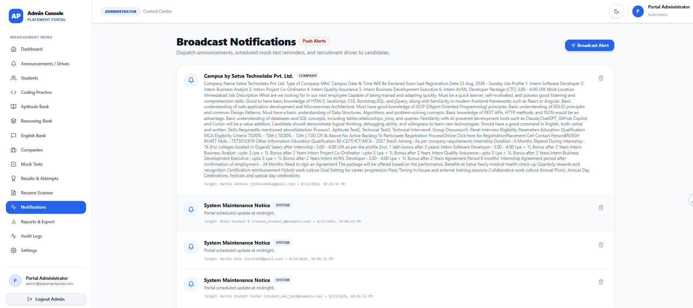
Figure 5.9.13 Notification
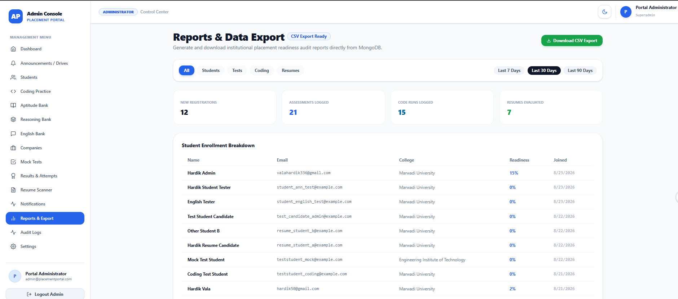

Figure 5.9.14 Report Data & Export
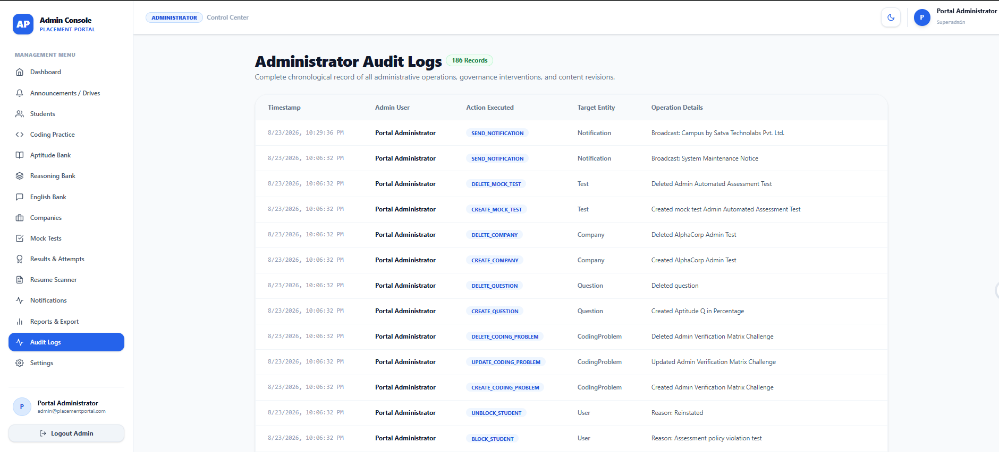
Figure 5.9.15 Audit Logs
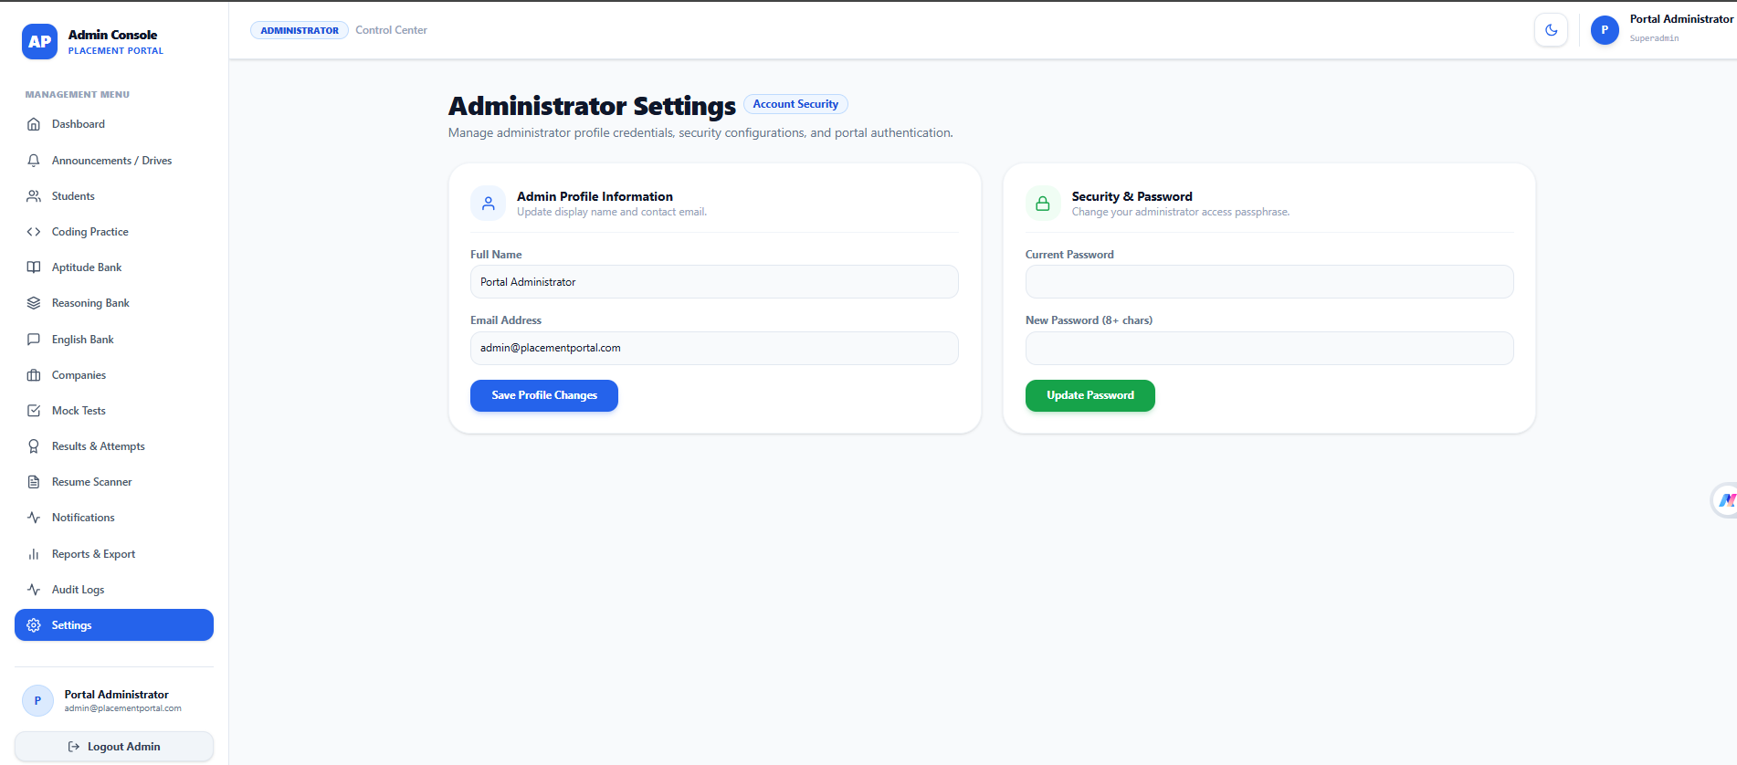
Figure 5.9.16 Settings

6. SYSTEM TESTING

Software testing was conducted following IEEE 829 Standard Test Documentation guidelines. Testing was performed to verify the correctness, reliability, usability, and functionality of the Placement Preparation Portal.
Both positive test cases (PASS) and negative test cases (FAIL/Exception Handling) were considered. The testing covered authentication, student modules, preparation modules, mock tests, coding practice, Resume Scanner, Admin Panel, and analytics.

Module 1: User Registration Testing
The User Registration module was tested to ensure that new students can successfully create an account using valid information and that invalid or incomplete information is properly rejected.
Test Case ID | Test Scenario | Test Input | Expected Result | Status
REG-01 | Register with valid details | Valid name, email, password | Account should be created successfully | PASS
REG-02 | Empty name field | Name left blank | Validation message should be displayed | PASS
REG-03 | Empty email field | Email left blank | Validation message should be displayed | PASS
REG-04 | Invalid email format | student@ | Invalid email message should be displayed | PASS
REG-05 | Empty password | Password left blank | Password validation message should appear | PASS
REG-06 | Weak password | Short/weak password | System should reject the password | PASS
REG-07 | Password mismatch | Different password and confirmation password | Mismatch error should be displayed | PASS
REG-08 | Existing email | Already registered email | System should prevent duplicate registration | PASS
REG-09 | Valid registration with optional fields | Valid required and optional information | Account should be created successfully | PASS
REG-10 | Database connection failure | Registration request when database unavailable | Appropriate error message should be displayed | PASS
Table 6.1 User Registration Testing

Testing Result
The User Registration module successfully validates user input and handles invalid registration scenarios. Duplicate accounts and incorrect input are rejected, while valid student information is stored successfully in the database.

Module 2: User Authentication & Login Testing:
The User Authentication and Login module was tested to ensure that registered students and administrators can securely access the system using valid credentials. Testing also verified that invalid credentials, unauthorized access, and authentication errors are handled appropriately.

Test Case ID | Test Scenario | Test Input | Expected Result | Status
AUTH-01 | Login with valid student credentials | Registered email and correct password | Student should be successfully logged in and redirected to Student Dashboard | PASS
AUTH-02 | Login with valid admin credentials | Admin email and correct password | Admin should be successfully logged in and redirected to Admin Dashboard | PASS
AUTH-03 | Incorrect password | Registered email with wrong password | Login should be rejected with an appropriate error message | PASS
AUTH-04 | Unregistered email | Email not present in database | System should display invalid credentials error | PASS
AUTH-05 | Empty email field | Email left blank | Email validation message should be displayed | PASS
AUTH-06 | Empty password field | Password left blank | Password validation message should be displayed | PASS
AUTH-07 | Invalid email format | Incorrect email format | System should display email validation error | PASS
AUTH-08 | Empty login form | Both fields left blank | Required field validation messages should be displayed | PASS
AUTH-09 | Student accessing Admin Panel | Student token attempts admin route | Access should be denied due to role-based authorization | PASS
AUTH-10 | Admin accessing Student features | Admin token attempts restricted student route | Unauthorized access should be prevented where applicable | PASS
AUTH-11 | Logout testing | Click Logout | User session/token should be cleared and user redirected to Login page | PASS
AUTH-12 | Access protected page without login | Directly open protected URL | User should be redirected to Login page | PASS
AUTH-13 | Invalid/expired JWT token | Expired or invalid authentication token | Request should be rejected and user should be asked to authenticate again | PASS
AUTH-14 | Login after logout | Valid credentials after logout | User should be able to log in successfully again | PASS
AUTH-15 | Database/server unavailable | Login request when backend/database is unavailable | System should display an appropriate error instead of crashing | PASS

Table 6.2 User Authentication & Login Test Case

Testing Result
The User Authentication and Login module successfully authenticates registered users and provides appropriate access according to their roles. Invalid credentials, unauthorized requests, expired authentication tokens, and protected-route access are handled correctly, ensuring secure access to the Placement Preparation Portal.

Module 3: Placement Content & Question Bank Management Testing:

Test Case ID | Test Scenario | Test Input | Expected Result | Status
CNT-01 | Add new preparation note | Valid title, subject, topic, and content | Note should be successfully added | PASS
CNT-02 | Add question with valid details | Question, options, answer, explanation | Question should be stored successfully | PASS
CNT-03 | Add coding problem | Valid problem statement and difficulty | Coding problem should be created successfully | PASS
CNT-04 | View content list | Open Notes/Questions section | All available records should be displayed | PASS
CNT-05 | Edit existing content | Modify title/content/question | Updated information should be saved successfully | PASS
CNT-06 | Delete content | Select an existing record and delete | Selected record should be removed | PASS
CNT-07 | Required field validation | Submit form with required fields empty | Validation messages should be displayed | PASS
CNT-08 | Invalid question data | Missing options or correct answer | System should reject invalid question data | PASS
CNT-09 | Difficulty validation | Select Easy/Medium/Hard | Selected difficulty should be stored correctly | PASS
CNT-10 | Search content | Enter valid keyword | Matching notes/questions should be displayed | PASS
CNT-11 | Filter content | Select subject/topic/difficulty | Relevant records should be displayed | PASS
CNT-12 | Student content access | Student opens preparation module | Admin-created content should be displayed to the student | PASS
CNT-13 | Updated content synchronization | Admin edits existing content | Updated content should be reflected in Student Panel | PASS
CNT-14 | Unauthorized content management | Student attempts Admin CRUD operation | Access should be denied | PASS
CNT-15 | Database/server error | Database unavailable during operation | Appropriate error message should be displayed without crashing | PASS

Table 6.3 Product & Inventory Management Testing
Testing Result
The Placement Content and Question Bank Management module successfully performs CRUD operations for preparation content. The testing confirms that administrators can manage notes, questions, and coding problems, while students can access the updated.

Module 4: Mock Test & Assessment Testing
Test Case ID | Test Scenario | Test Input | Expected Result | Status
TEST-01 | Open available mock tests | Student selects Mock Test | Available tests should be displayed | PASS
TEST-02 | Start aptitude test | Select Aptitude Mock Test | Test should start successfully | PASS
TEST-03 | Start reasoning test | Select Reasoning Mock Test | Test should start successfully | PASS
TEST-04 | Start English test | Select English Mock Test | Test should start successfully | PASS
TEST-05 | Start coding test | Select Coding Mock Test | Coding test should start successfully | PASS
TEST-06 | Start mixed placement test | Select Mixed Test | Mixed test should load correctly | PASS
TEST-07 | Verify 30 questions | Start configured 30-question test | Exactly 30 questions should be displayed | PASS
TEST-08 | Question navigation | Move between questions | Previous/Next navigation should work correctly | PASS
TEST-09 | Select answer | Select an option | Selected answer should be saved | PASS
TEST-10 | Change answer | Select another option | Previous answer should be replaced correctly | PASS
TEST-11 | Skip question | Move without selecting answer | Question should remain unanswered | PASS
TEST-12 | Timer functionality | Start timed test | Countdown timer should start correctly | PASS
TEST-13 | Timer expiration | Allow timer to reach zero | Test should be automatically submitted | PASS
TEST-14 | Manual submission | Click Submit Test | Test should be submitted successfully | PASS
TEST-15 | Correct answer scoring | Submit correct answers | Correct answers should receive marks | PASS
TEST-16 | Incorrect answer scoring | Submit incorrect answers | Incorrect answers should be evaluated correctly | PASS
TEST-17 | Negative marking | Submit incorrect answer in negative-marking test | Applicable negative marks should be deducted | PASS
TEST-18 | Result generation | Complete test | Score, correct, incorrect, and skipped answers should be displayed | PASS
TEST-19 | Result persistence | Complete and submit test | Result should be saved in MongoDB | PASS
TEST-20 | Performance analysis | View completed test result | Accuracy, percentage, and performance analysis should be displayed | PASS
TEST-21 | Test history | Open previous test attempts | Previous test results should be displayed | PASS
TEST-22 | Unauthorized test submission | Invalid/expired authentication token | Submission should be rejected | PASS
TEST-23 | Refresh during test | Refresh test page | System should handle the session appropriately without corrupting the test result | PASS
TEST-24 | Server/database failure | Submit test when server/database unavailable | Appropriate error should be displayed | PASS
Table 6.4 Mock Test & Assessment Testing

Testing Result
The Mock Test and Assessment module successfully performs test initialization, question navigation, timer management, answer submission, scoring, negative marking, automatic submission, and result generation. Test results are stored in the database and are used to provide students with detailed performance analysis and progress tracking.

7. CONCLUSION

The Placement Preparation Portal was developed as a comprehensive web-based platform to help students prepare effectively for campus placements through a single centralized system. The project integrates multiple placement preparation activities, including Aptitude, Reasoning, English, Programming Languages, Coding Practice, Mock Tests, Company Preparation, Resume Scanner, AI-assisted Interview Preparation, and Performance Analytics.

The system provides students with topic-wise study material, practice questions, quizzes, coding challenges, and timed mock tests. Students can view their test results, track their preparation progress, identify weak areas, and improve their overall placement readiness. The Resume Scanner further helps students review their resumes and receive suggestions for improvement.

The Admin Panel provides centralized and dynamic management of students, notes, questions, coding problems, companies, mock tests, and results. This allows preparation content to be updated without modifying the application manually.

The project was developed using the MERN Stack, consisting of React.js for the frontend, Node.js and Express.js for backend services, and MongoDB with Mongoose for data management. JWT authentication and role-based access control provide secure access for students and administrators.

Overall, the Placement Preparation Portal provides a structured, accessible, and interactive environment for student placement preparation. It reduces the need to use multiple platforms and brings learning, practice, assessment, resume improvement, and performance tracking together in one system. The project can also be further enhanced in the future with advanced AI interview simulations, additional company question banks, real-time coding evaluation, personalized learning recommendations, and mobile application support.

8. LEARNING DURING PROJECT WORK

During the development of the Placement Preparation Portal, several technical and practical skills were gained through the design, development, testing, and integration of the system.
- MERN Stack Development
Gained practical experience in developing a complete web application using React.js, Node.js, Express.js, MongoDB, and Mongoose.
- Frontend Development
Learned how to create responsive and user-friendly interfaces using React.js, reusable components, routing, forms, dashboards, and modern UI techniques.
- Backend Development
Developed an understanding of creating REST APIs using Node.js and Express.js and connecting different frontend modules with backend services.
- Database Management
Learned how to design MongoDB collections and manage student profiles, questions, notes, tests, results, coding problems, companies, resumes, and progress data.
- Authentication and Authorization
Gained practical knowledge of JWT-based authentication, password security using bcryptjs, protected routes, and role-based access for Students and Admins.
- API Integration
Learned how to connect frontend components with backend APIs using Axios and handle data requests, responses, validation, and errors.
- Dynamic Content Management
Learned how an Admin Panel can dynamically create, update, delete, and manage preparation content that is displayed to students.
- Testing and Debugging
Developed skills in identifying errors, testing positive and negative scenarios, debugging frontend and backend issues, and improving system reliability.
- Mock Test and Result Processing
Learned how to implement timed tests, question navigation, answer submission, scoring, negative marking, result generation, and performance analysis.
- Project Architecture
Gained practical understanding of MVC architecture, modular development, reusable components, API organization, and maintaining a structured project.
- Problem-Solving Skills
The project helped improve logical thinking and problem-solving skills by handling real-world requirements, database relationships, authentication issues, and module integration.
- Project Management
Learned to divide a large application into smaller modules and develop, test, and integrate each module systematically.
- Documentation Skills
Gained experience in preparing technical documentation, system design diagrams, testing documentation, and project reports.
- Deployment and Production Concepts
Developed an understanding of environment variables, production configuration, API security, database connectivity, and deployment requirements.

8.1 Future Enhancement:

The Placement Preparation Portal can be further enhanced with advanced features to make the system more intelligent, personalized, and useful for students.
- Advanced AI Interview System
An AI-based virtual interviewer can conduct real-time technical and HR interviews and provide feedback on student performance.

- Personalized Learning Recommendations
The system can analyze a student's test results and automatically recommend topics, questions, and study material based on their weak areas.

- AI-Based Resume Analysis
The Resume Scanner can be enhanced with advanced ATS analysis, keyword matching, resume scoring, and job-specific resume recommendations.

- Online Coding Compiler
A real-time coding environment can be integrated so students can write, compile, and execute programs directly within the portal.

- More Company-Specific Content
The company preparation module can be expanded with regularly updated aptitude, coding, technical, and HR questions from more companies.

- Mobile Application
A dedicated Android/iOS application can be developed to allow students to access preparation material and tests from mobile devices.

- Real-Time Leaderboard
A real-time leaderboard can be introduced to encourage healthy competition among students based on test scores, coding performance, and preparation progress.

- Advanced Analytics
More detailed analytics can be added to identify performance trends, topic-wise weaknesses, study patterns, and overall placement readiness.

- Notifications and Reminders
The system can provide personalized notifications for upcoming tests, recommended practice, study reminders, and placement-related updates.

- Multilingual Support
The portal can support multiple languages so that students can access preparation content in their preferred language.

- Cloud-Based Scalability
The application can be deployed using cloud infrastructure to support a larger number of students and provide reliable access.

9. BIBLIOGRAPHY

9.1 Online References:

- React.js Documentation — https://react.dev/
- Vite Documentation — https://vite.dev/
- Node.js Documentation — https://nodejs.org/docs/
- Express.js Documentation — https://expressjs.com/
- MongoDB Documentation — https://www.mongodb.com/docs/
- Mongoose Documentation — https://mongoosejs.com/docs/
- JWT — https://jwt.io/
- Axios Documentation — https://axios-http.com/docs/intro
- Tailwind CSS Documentation — https://tailwindcss.com/docs
- Mermaid Documentation — https://mermaid.js.org/
- MDN Web Docs — https://developer.mozilla.org/
- GitHub Documentation — https://docs.github.com/
- OpenAI Documentation — https://platform.openai.com/docs/

9.2 Offline References:

The following offline references were used for understanding software engineering concepts, system design, database management, web development, and software testing during the development of the Placement Preparation Portal.
- Pressman, R. S. — Software Engineering: A Practitioner's Approach, McGraw-Hill Education.
- Sommerville, Ian — Software Engineering, Pearson Education.
- Silberschatz, Abraham, Henry F. Korth, and S. Sudarshan — Database System Concepts, McGraw-Hill.
- Eloquent JavaScript — Marijn Haverbeke, No Starch Press.
- JavaScript: The Definitive Guide — David Flanagan, O'Reilly Media.
- Learning Web Design — Jennifer Niederst Robbins, O'Reilly Media.
- Node.js Design Patterns — Mario Casciaro and Luciano Mammino, Packt Publishing.
- MongoDB: The Definitive Guide — Shannon Bradshaw, Eoin Brazil, and Kristina Chodorow, O'Reilly Media.
- Clean Code — Robert C. Martin, Prentice Hall.
- System Analysis and Design — Kenneth E. Kendall and Julie E. Kendall, Pearson Education.

